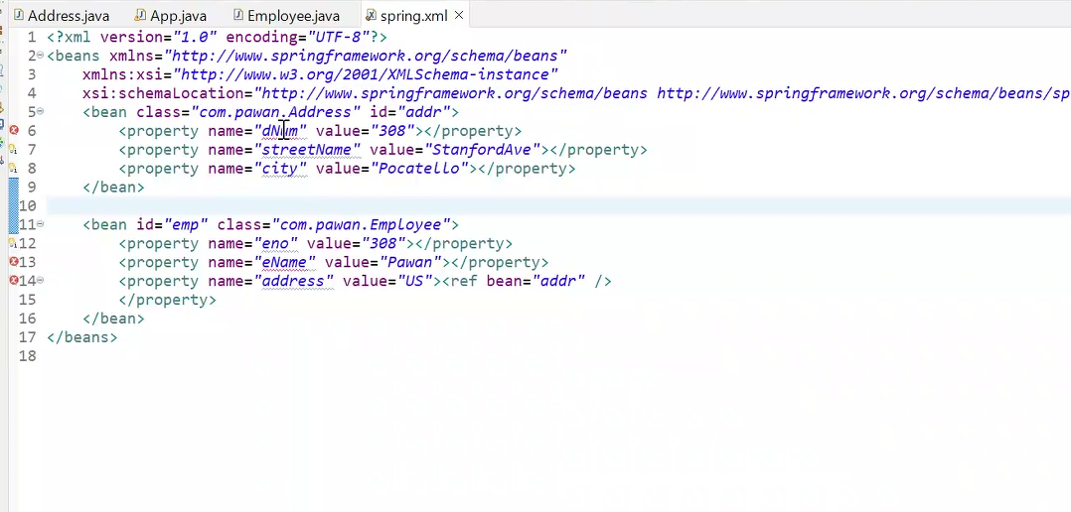

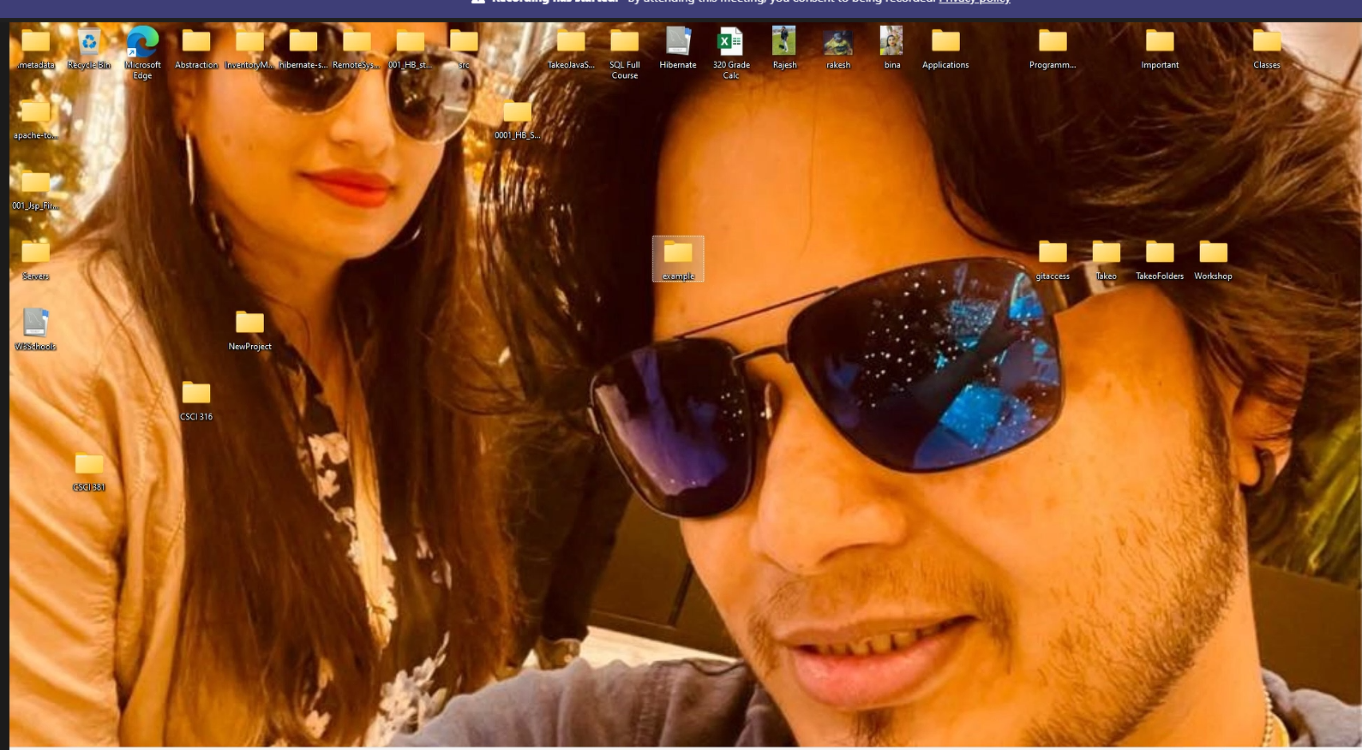

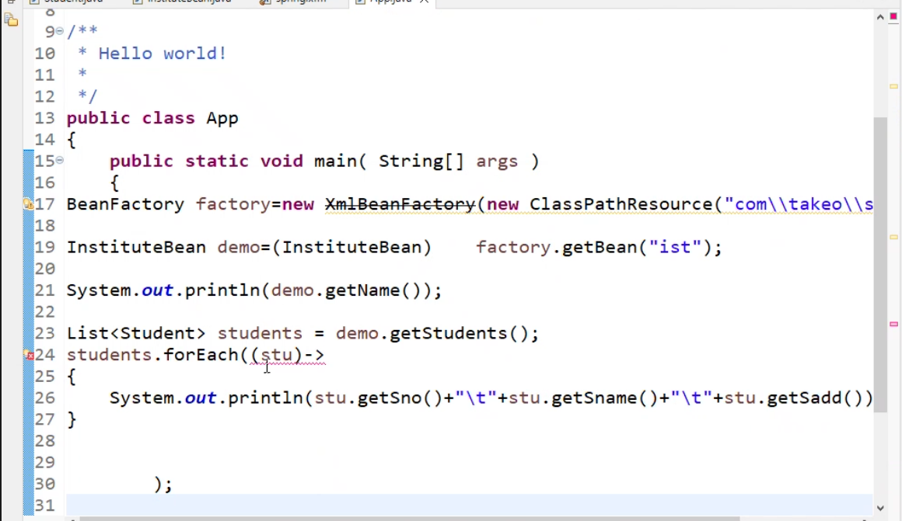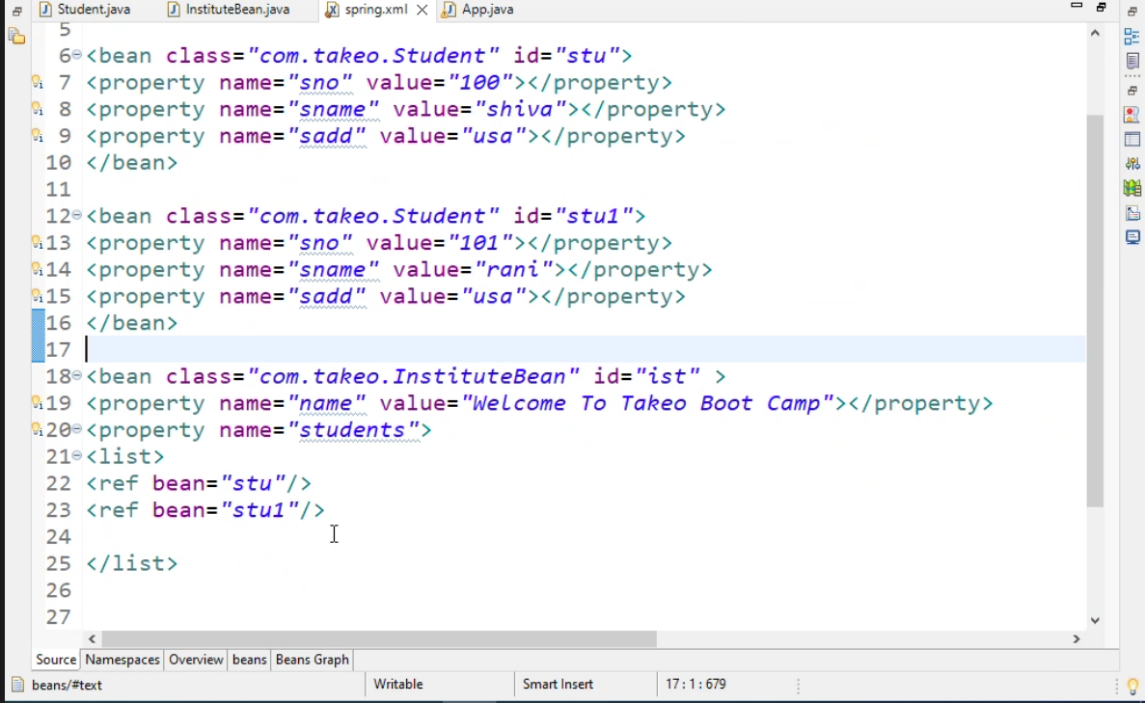

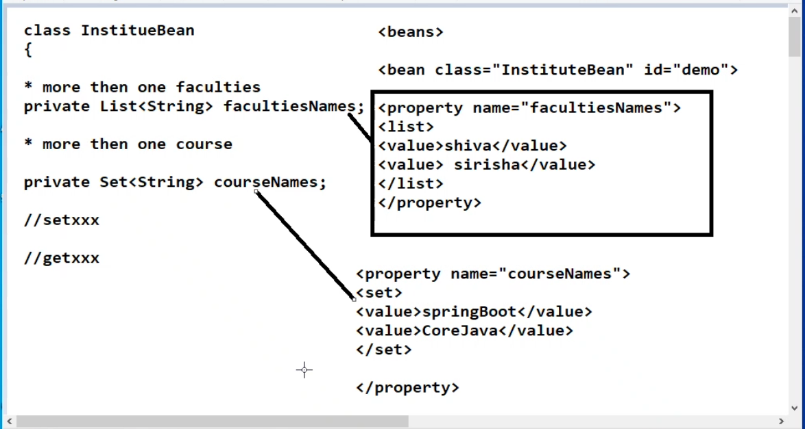

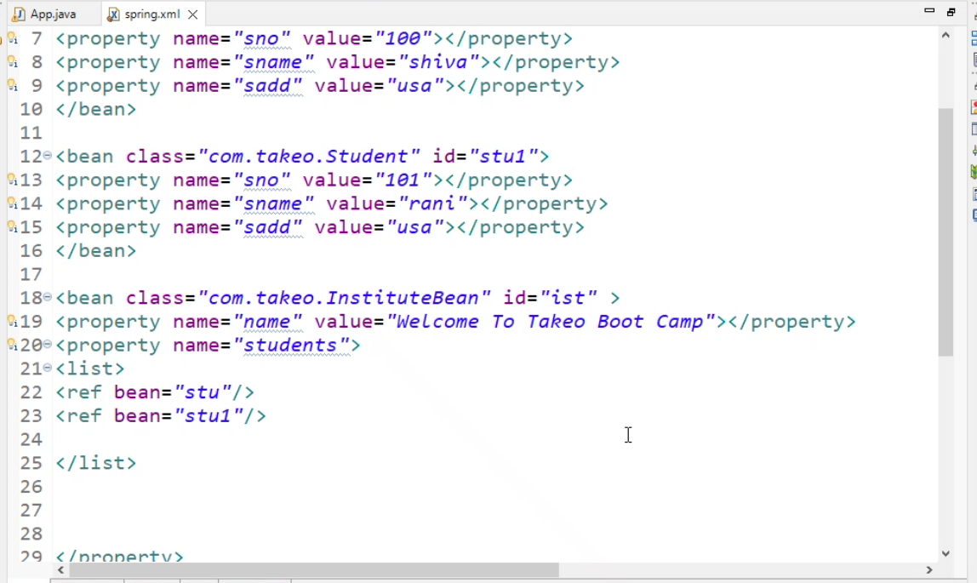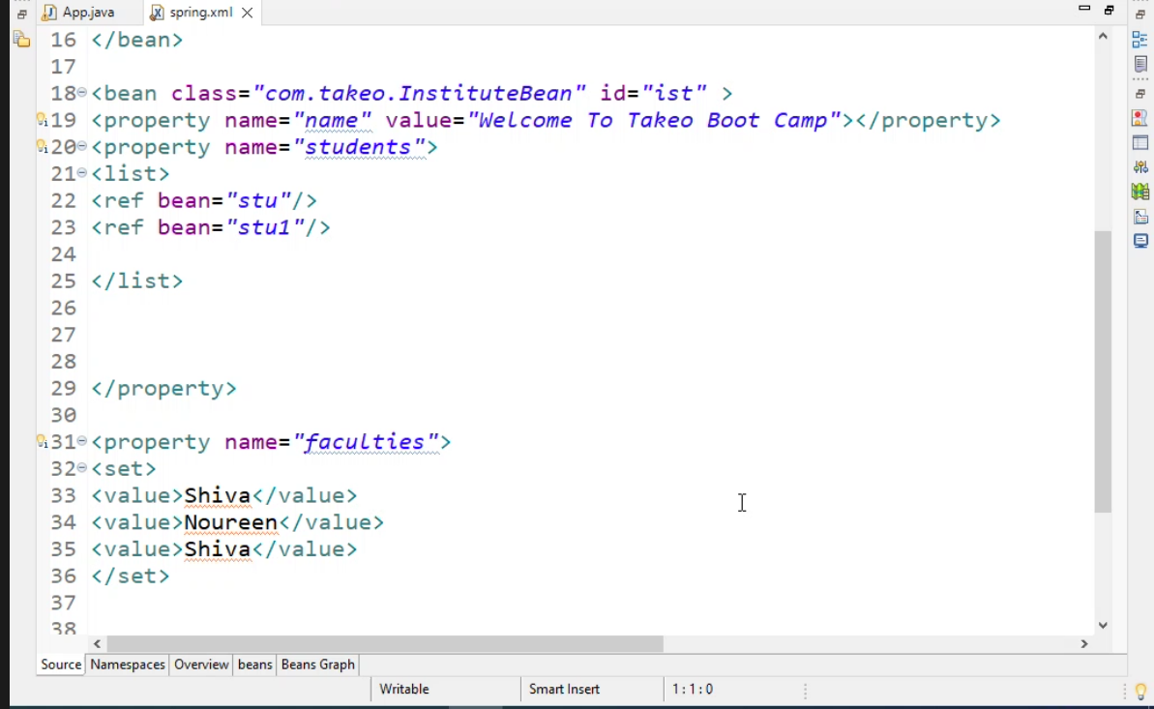

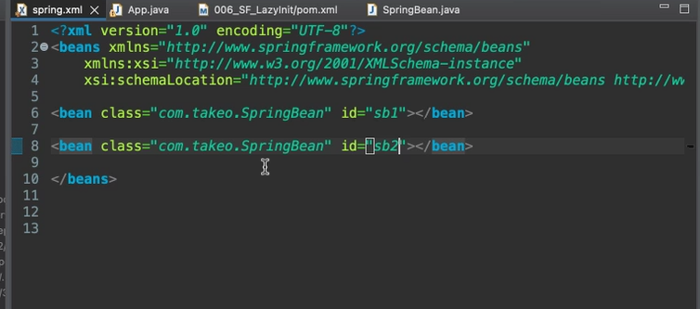

<!-- <https://mvnrepository.com/artifact/org.springframework/spring-core> -->  
<dependency>  
<groupId>org.springframework</groupId>  
<artifactId>spring-core</artifactId>  
<version>5.3.9</version>  
</dependency>

<!-- <https://mvnrepository.com/artifact/org.springframework/spring-beans> -->  
<dependency>  
<groupId>org.springframework</groupId>  
<artifactId>spring-beans</artifactId>  
<version>5.3.12</version>  
</dependency>

<!-- <https://mvnrepository.com/artifact/org.springframework/spring-context> -->  
<dependency>  
<groupId>org.springframework</groupId>  
<artifactId>spring-context</artifactId>  
<version>5.3.9</version>  
</dependency>

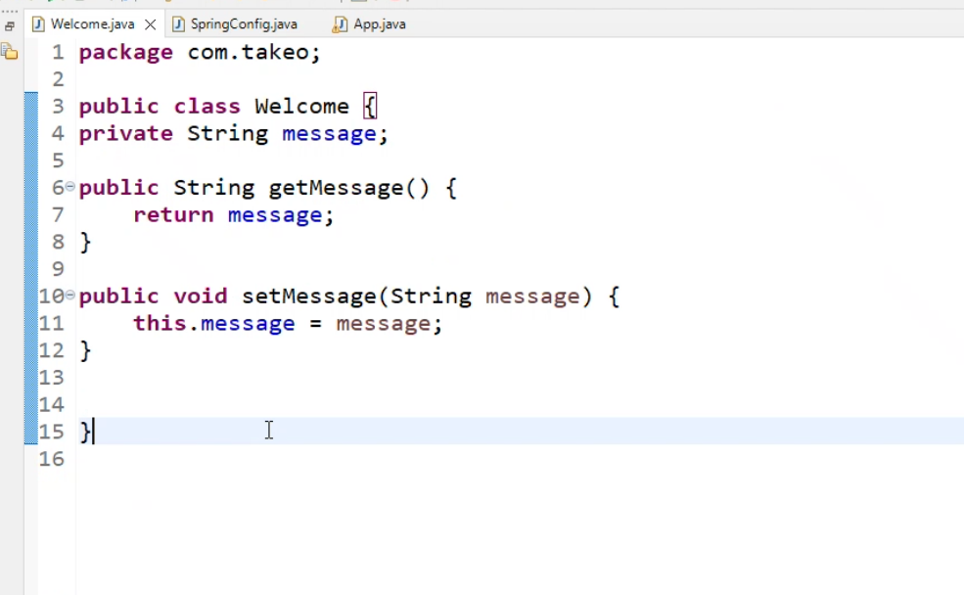

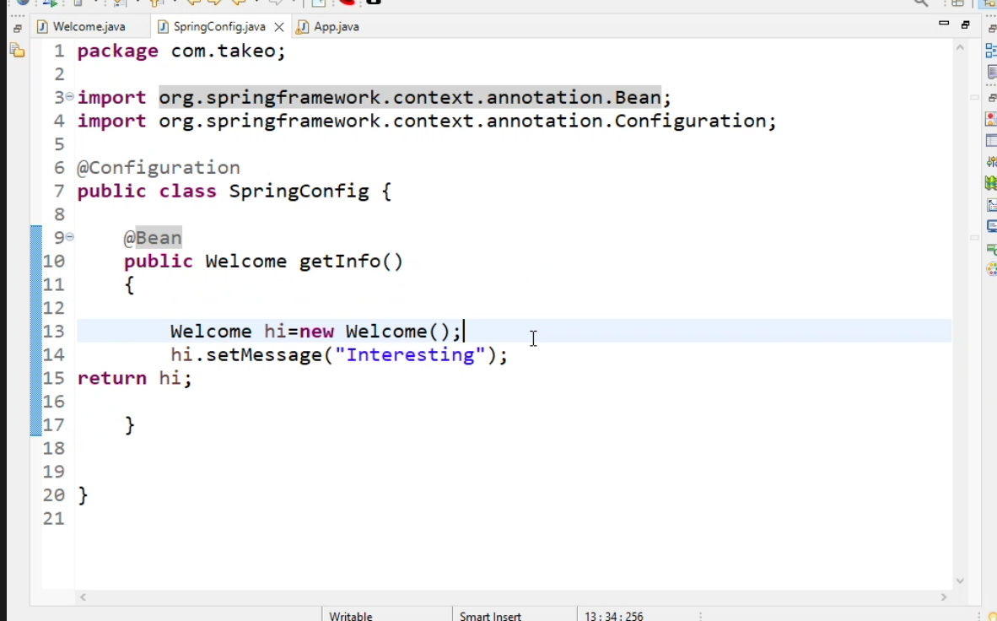

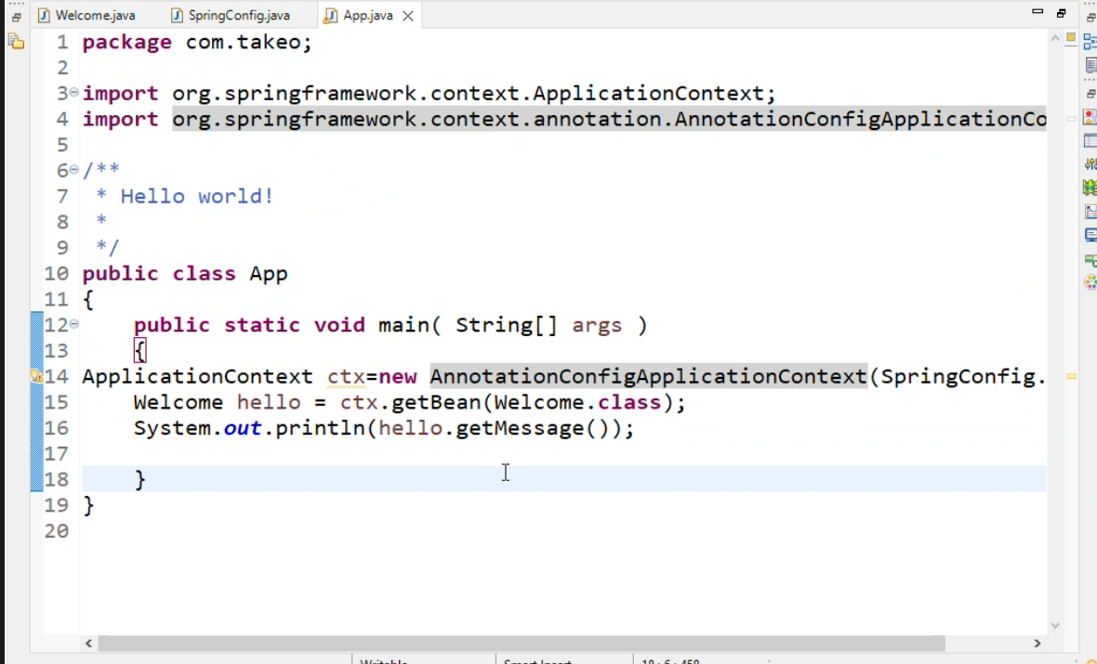

Dispatcher Servlet:

* Act as security guide
* Pre class controller, take the request coming from client
* Handler mapper identity the control gives back to DS. take the request and
* Handler mappers identify and return to Dispatcher
* DS will pass to Controller to execute the
* And Return to Dispatcher with Modul and view as JSP page
* DS-> viewResover identify the view component give response back to Dispatcher
* Dispatcher Servlet give JPS page and response back to DS to Client.

1. What are the built in HandlerMappers?

* SimpleUrlHanderMapping
* BeanNameUrlHandlerMapping
* ClassPathUrlHanlerMapping

Nowday no one using this, so Instede of Using thesre handler mappings we can use following:

* @RequestMapping

1. What are the built in Controllers?

* SimpleFormController
* MultiActionController
* WizardFormController
* Controller(I)
* AbstractCommandController

Now days no one using, instead we are using

* @Controller

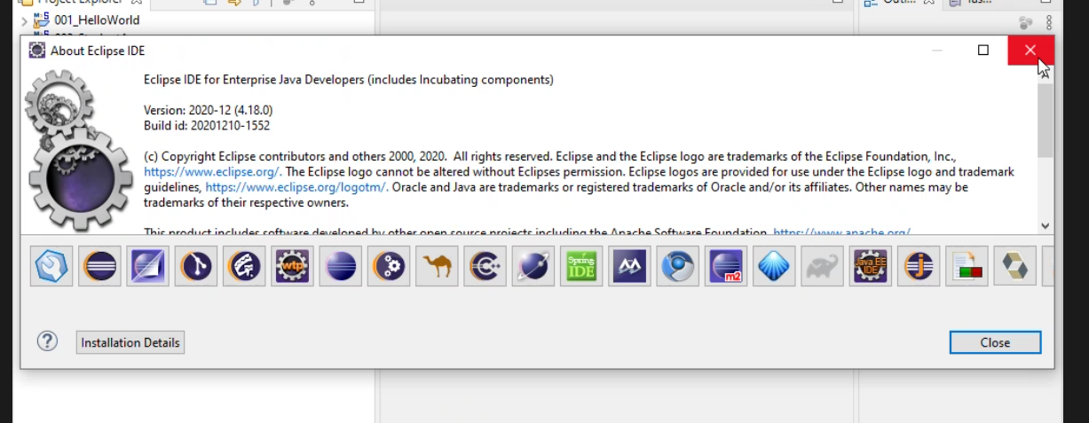

Spring:

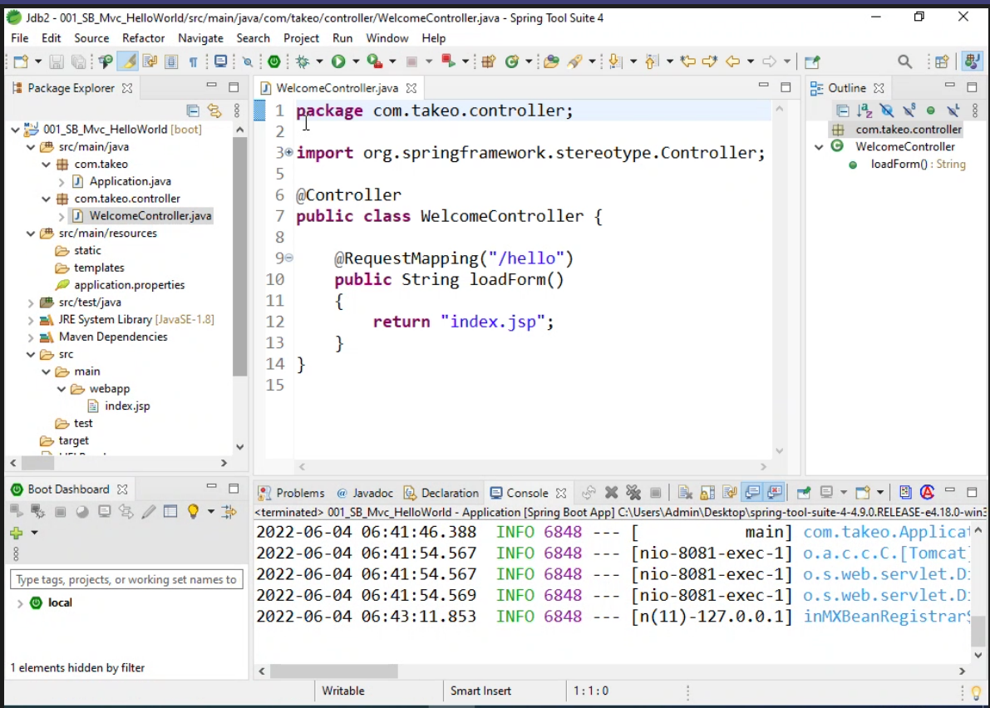

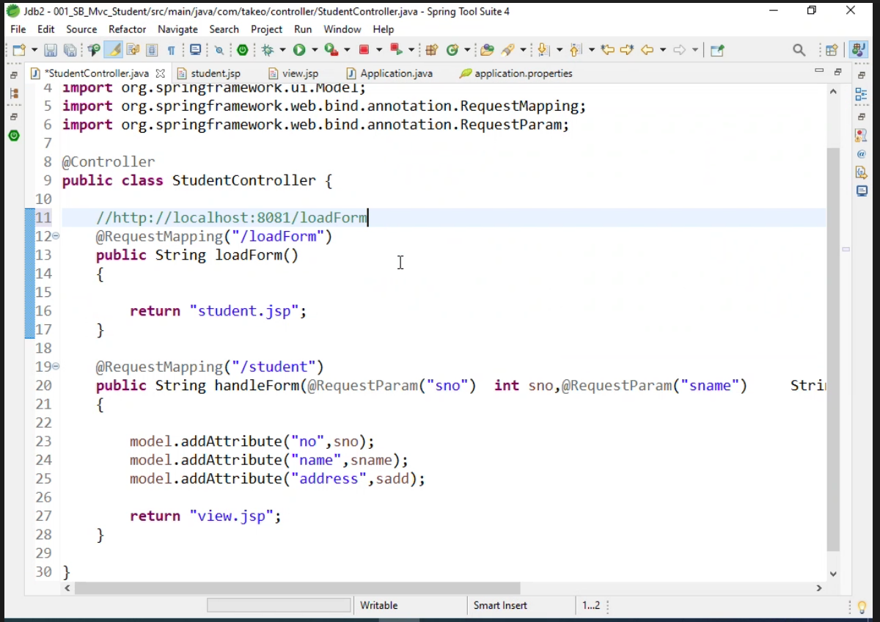

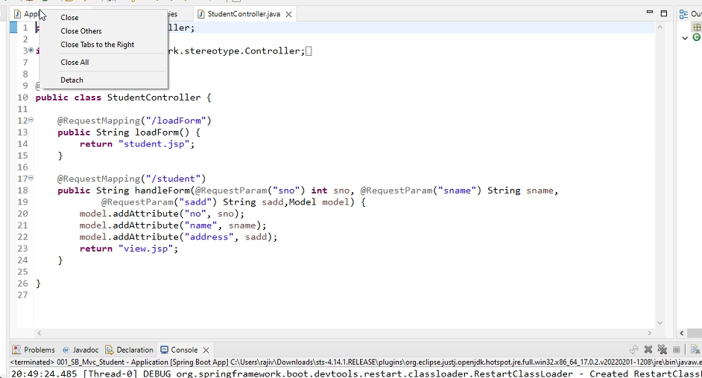

How to create JSP project in Spring.

1. In Pom.xml add following dependency

<?xml version=*"1.0"* encoding=*"UTF-8"*?>

<project xmlns=*"http://maven.apache.org/POM/4.0.0"*

xmlns:xsi=*"http://www.w3.org/2001/XMLSchema-instance"*

xsi:schemaLocation=*"http://maven.apache.org/POM/4.0.0 https://maven.apache.org/xsd/maven-4.0.0.xsd"*>

<modelVersion>4.0.0</modelVersion>

<parent>

<groupId>org.springframework.boot</groupId>

<artifactId>spring-boot-starter-parent</artifactId>

<version>2.7.0</version>

<relativePath /> <!-- lookup parent from repository -->

</parent>

<groupId>com.example</groupId>

<artifactId>002_SB_MVC_Student</artifactId>

<version>0.0.1-SNAPSHOT</version>

<name>002_SB_MVC_Student</name>

<description>Demo project for Spring Boot</description>

<properties>

<java.version>1.8</java.version>

</properties>

<dependencies>

<dependency>

<groupId>org.springframework.boot</groupId>

<artifactId>spring-boot-starter-web</artifactId>

</dependency>

<dependency>

<groupId>org.springframework.boot</groupId>

<artifactId>spring-boot-devtools</artifactId>

<scope>runtime</scope>

<optional>true</optional>

</dependency>

<dependency>

<groupId>org.springframework.boot</groupId>

<artifactId>spring-boot-starter-test</artifactId>

<scope>test</scope>

</dependency>

<dependency>

<groupId>org.springframework.boot</groupId>

<artifactId>spring-boot-starter-tomcat</artifactId>

</dependency>

<!-- https://mvnrepository.com/artifact/org.apache.tomcat.embed/tomcat-embed-jasper -->

<dependency>

<groupId>org.apache.tomcat.embed</groupId>

<artifactId>tomcat-embed-jasper</artifactId>

</dependency>

<dependency>

<groupId>org.springframework</groupId>

<artifactId>spring-beans</artifactId>

<version>5.3.12</version>

</dependency>

</dependencies>

<build>

<plugins>

<plugin>

<groupId>org.springframework.boot</groupId>

<artifactId>spring-boot-maven-plugin</artifactId>

</plugin>

</plugins>

</build>

</project>

1. Create Project as Spring stater project.
2. Create WebApp folder under SCR folder
3. Create JSP file in WebApp with .jsp extension
4. Add HTML, CSS code in JSP file.

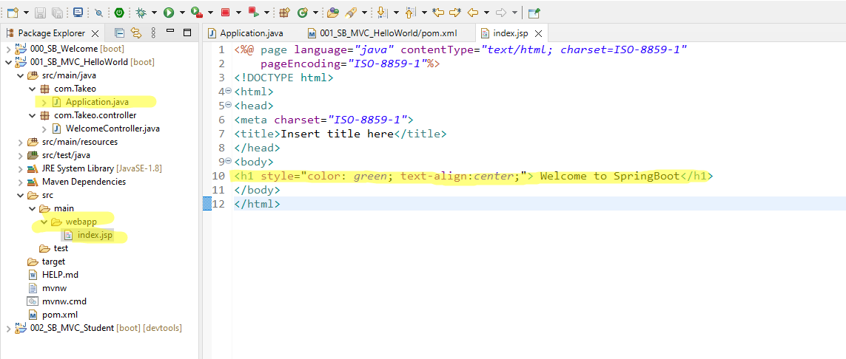

1. Add Class as Controller as WelcomeController. And add Controller package.
2. Add Controller tag annotation to make class as Controller.
3. @RequestMapping will configure the JSP page.
4. (“/hello”) will use while pulling in the website.

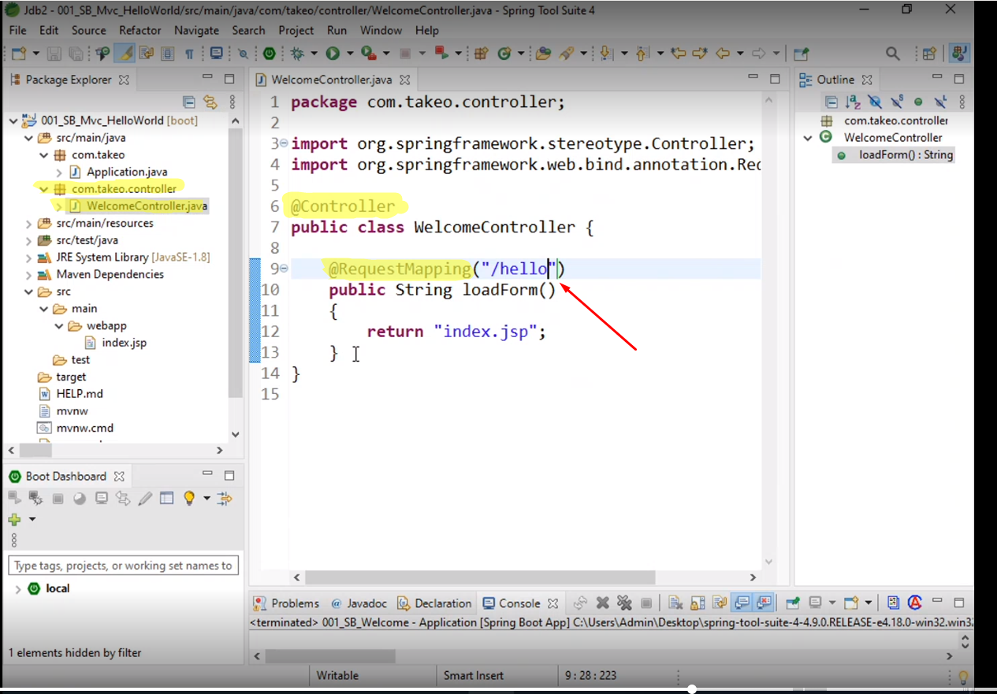

1. Change the port number of Tomcat

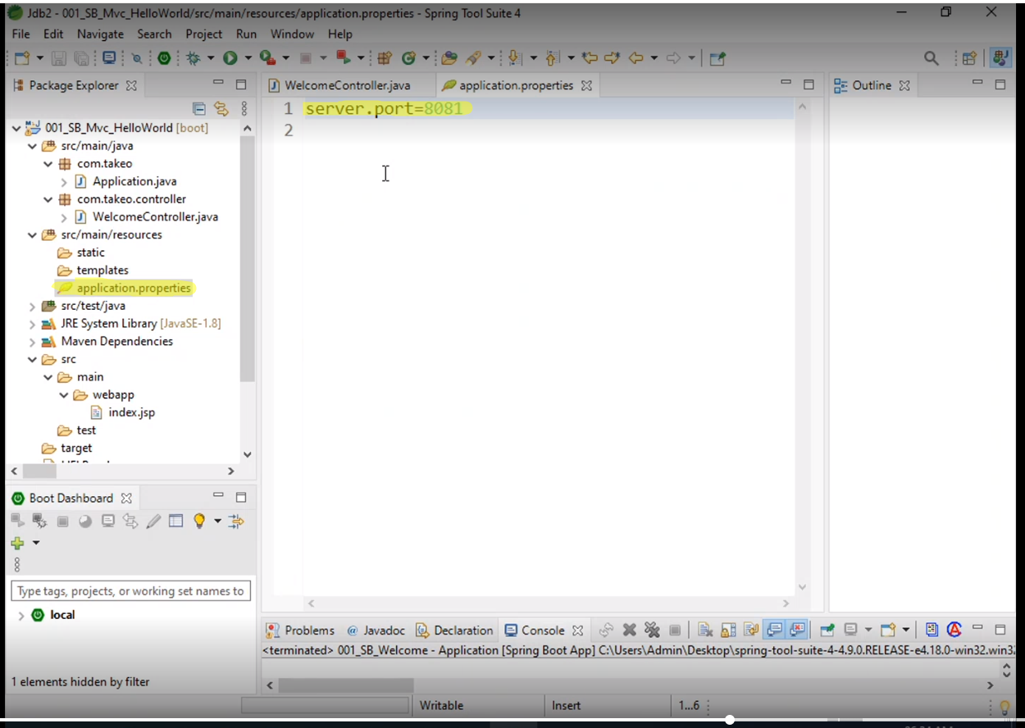

1. Run the app
2. 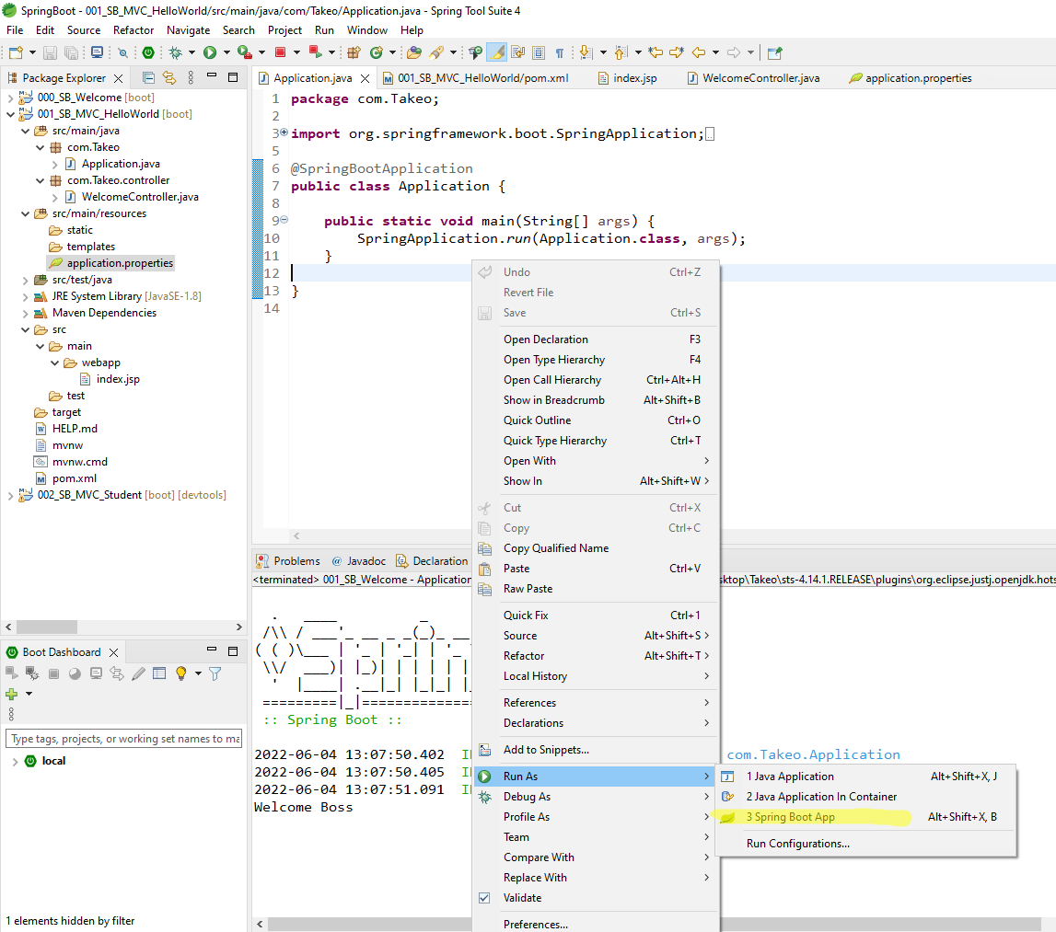
3. Enter the url in web page like “http://local:8082/hello”

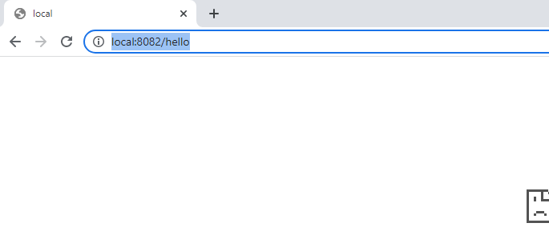

Example 2:

How to create a MVC Project.

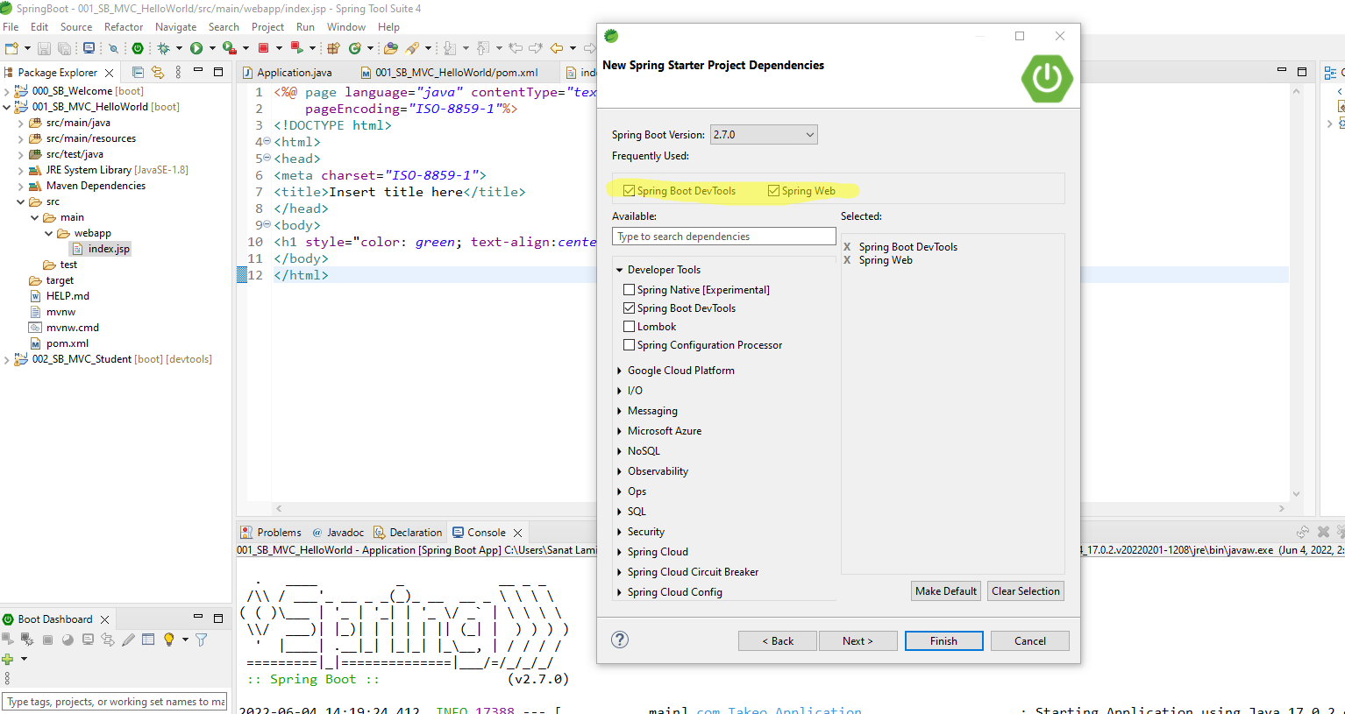

Create web app folder

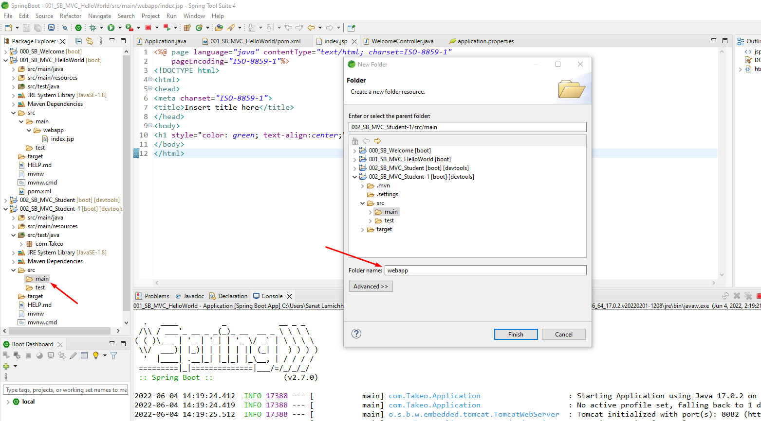

Create Student Controller class

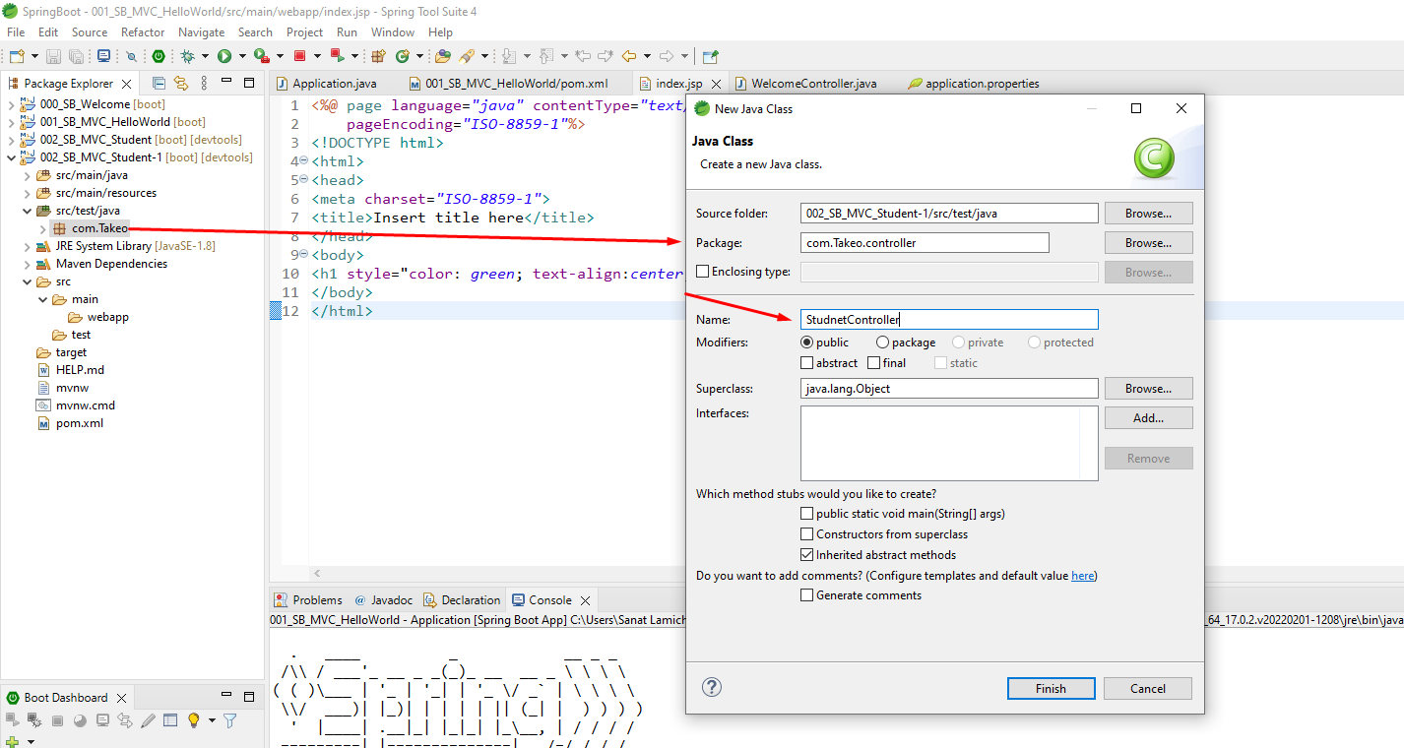

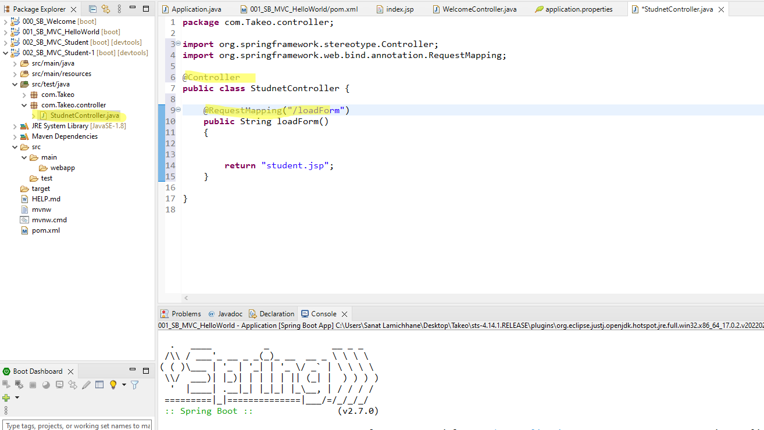

Create JSP file

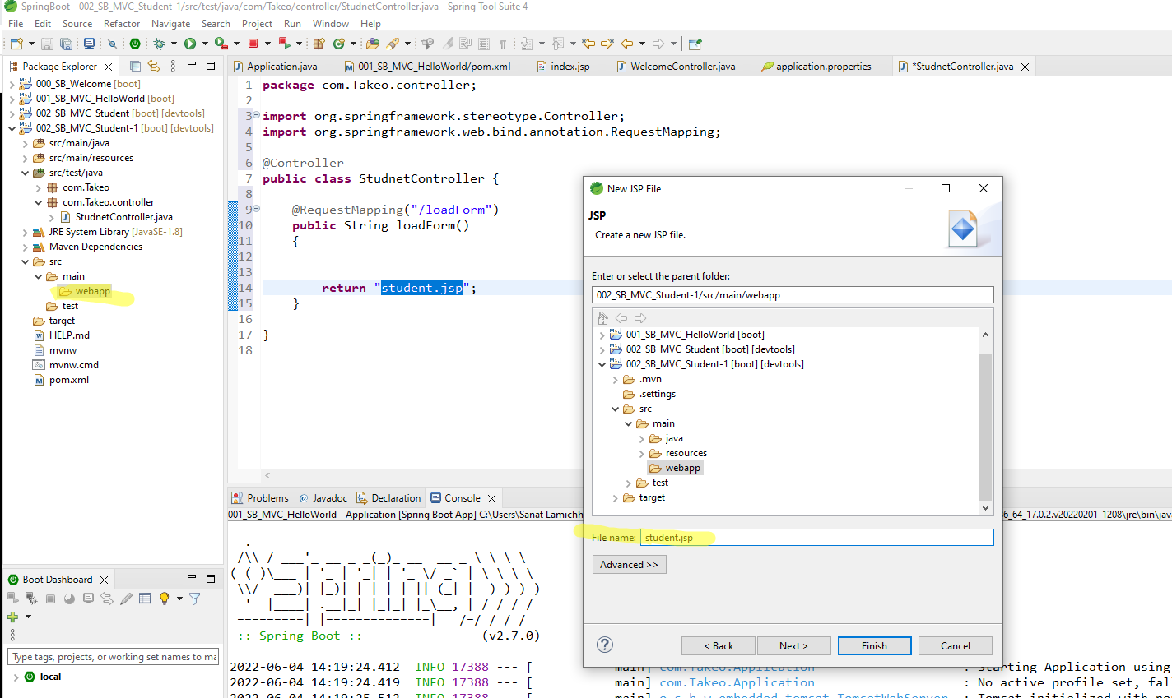

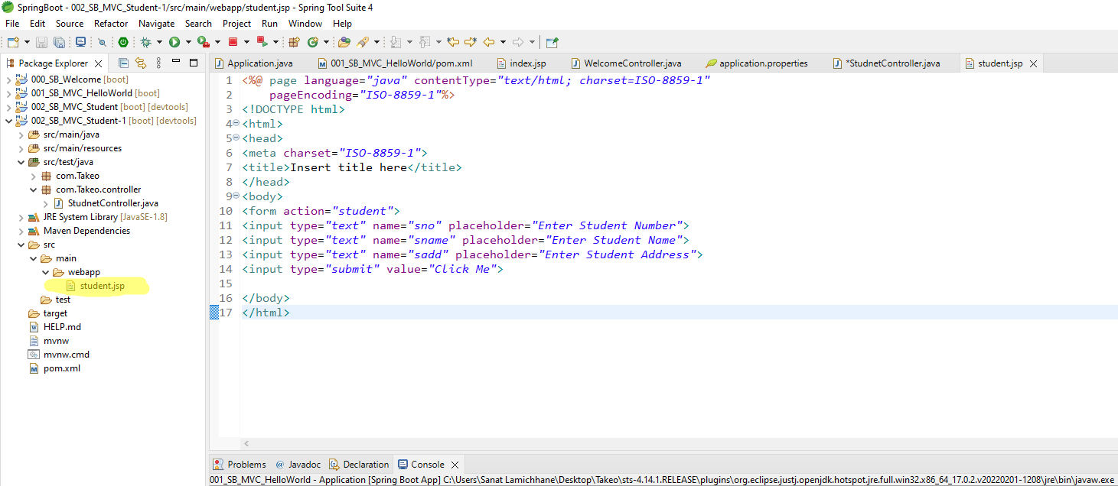

Update Controller class with following details

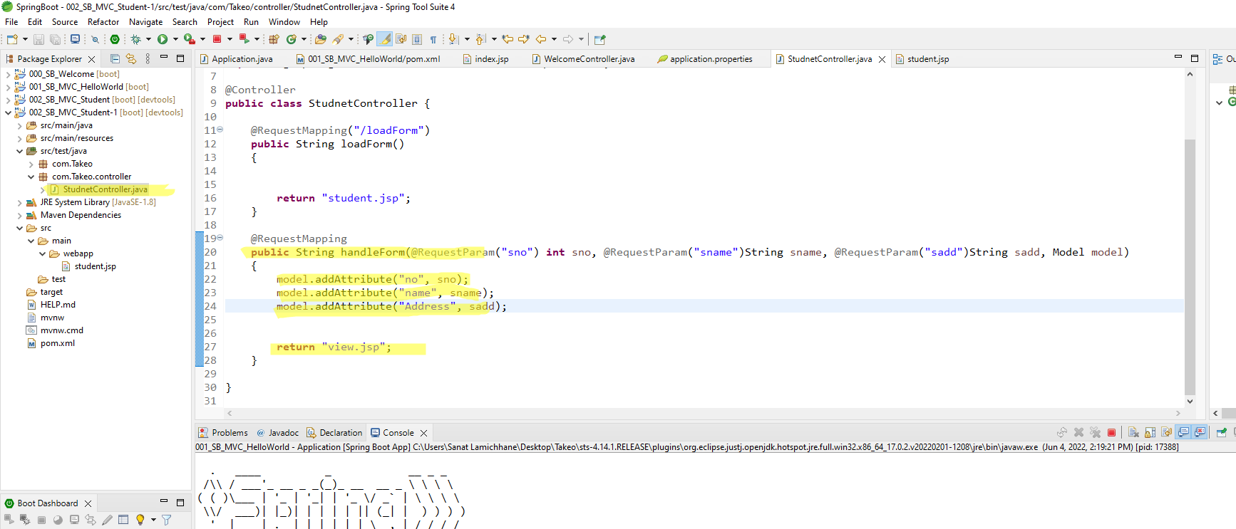

Now create another JSP field called view.jsp

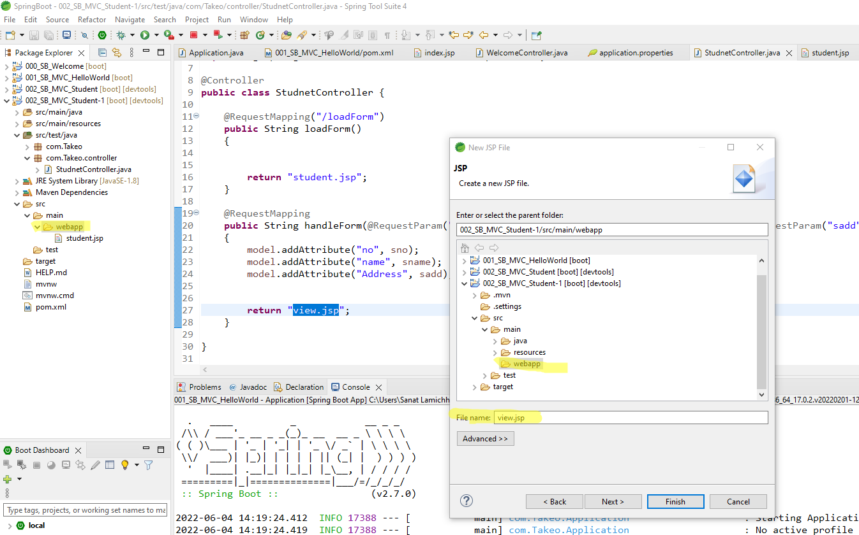

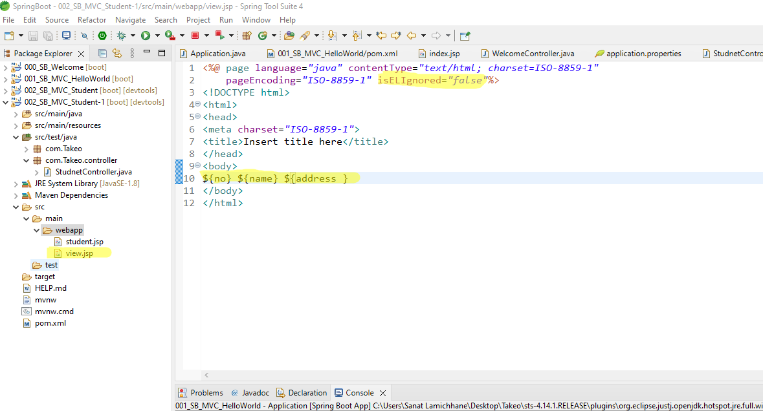

Update Tomcat dependency

Note: Update these two dependencies before run the application which means in between Start Web and DevTools.

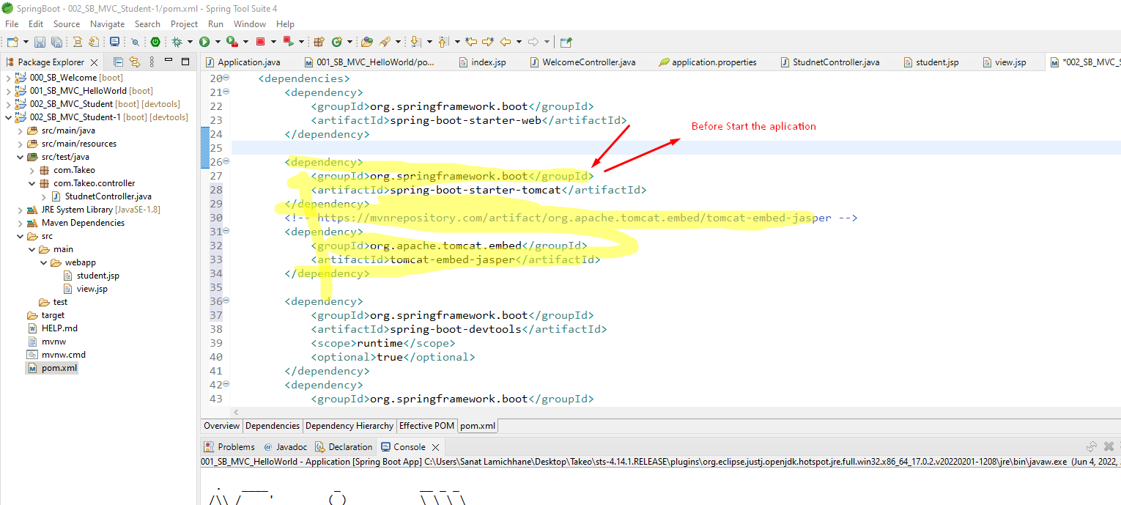

Update server port number

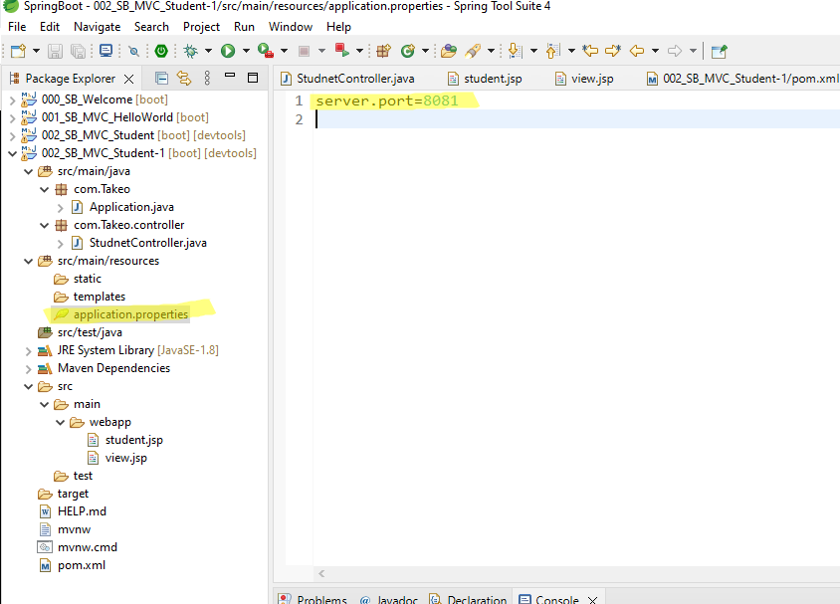

Start the server

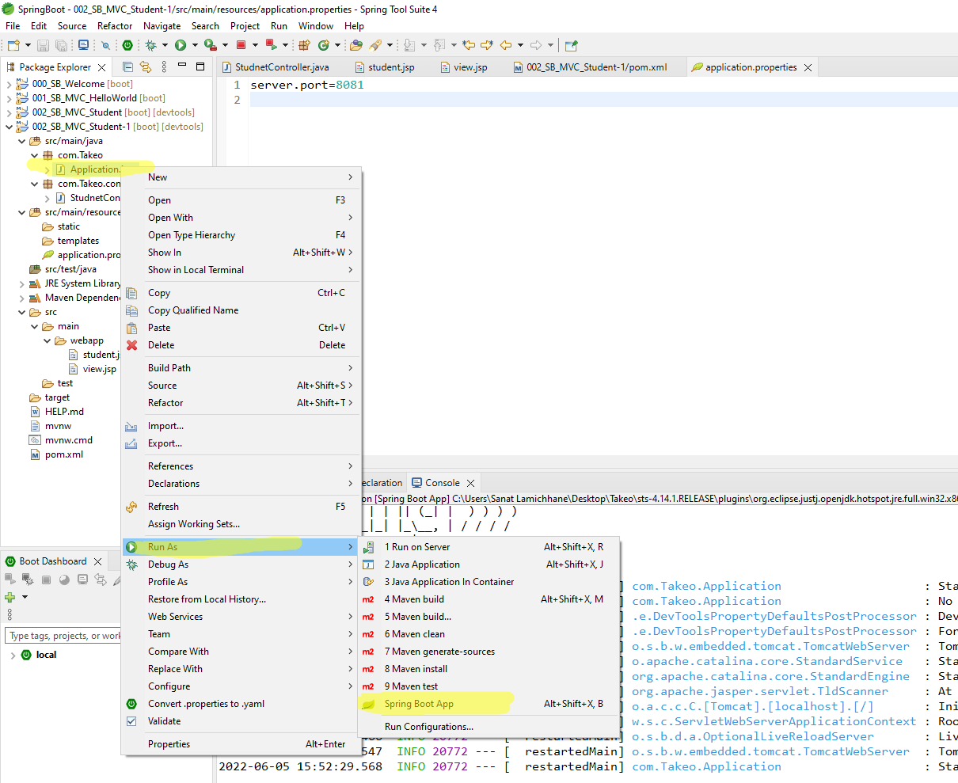

Enter following url in Browser

<http://localhost:8081/loadForm>

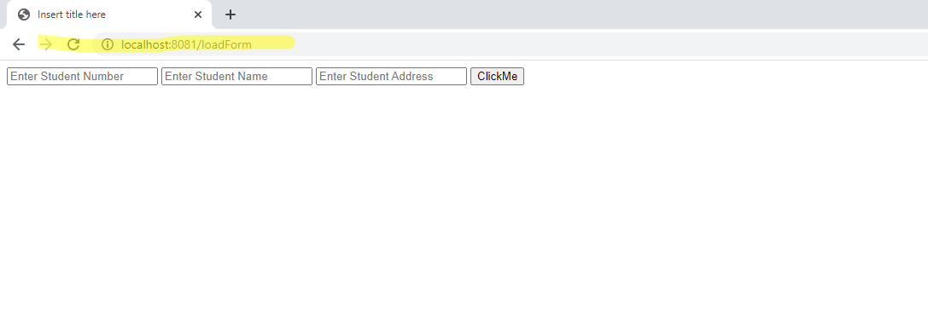

Enter the value

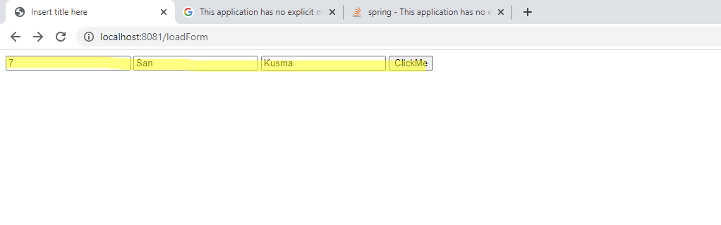

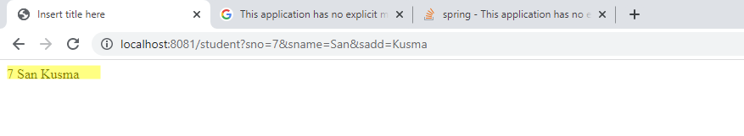

Date : 6/6/2022

# Day 41: Spring Boot

## Sprint JPA

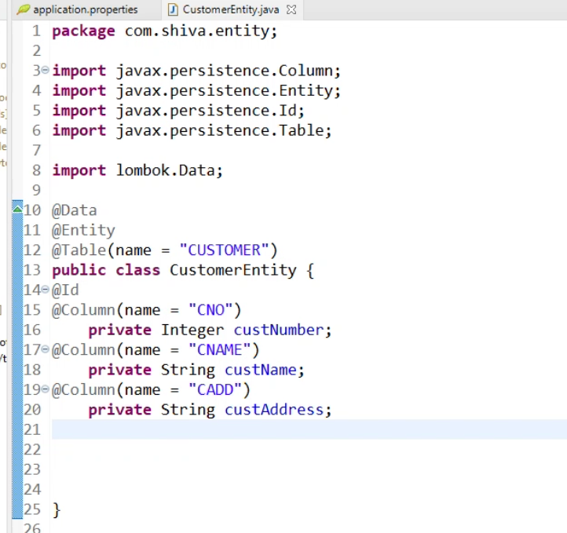

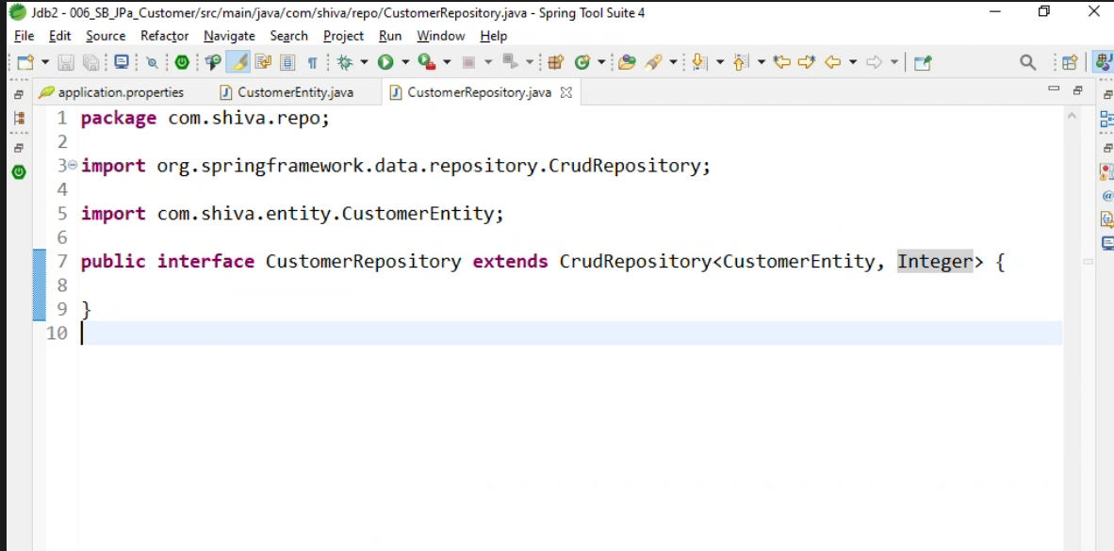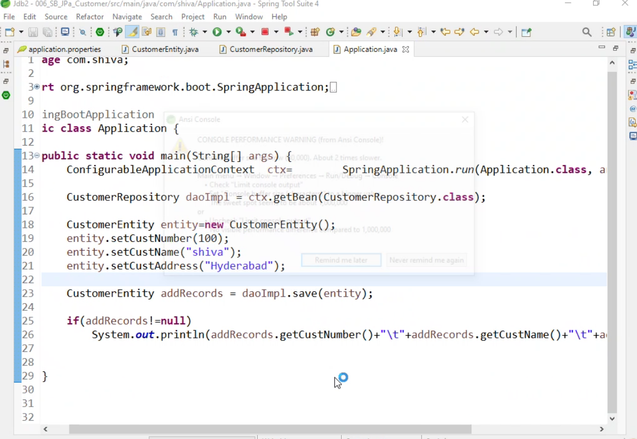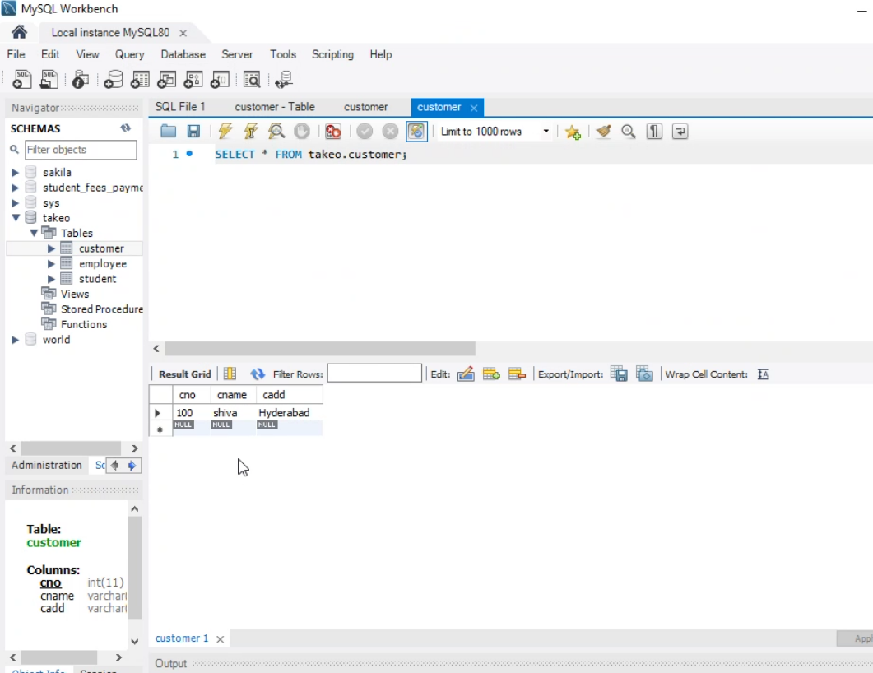

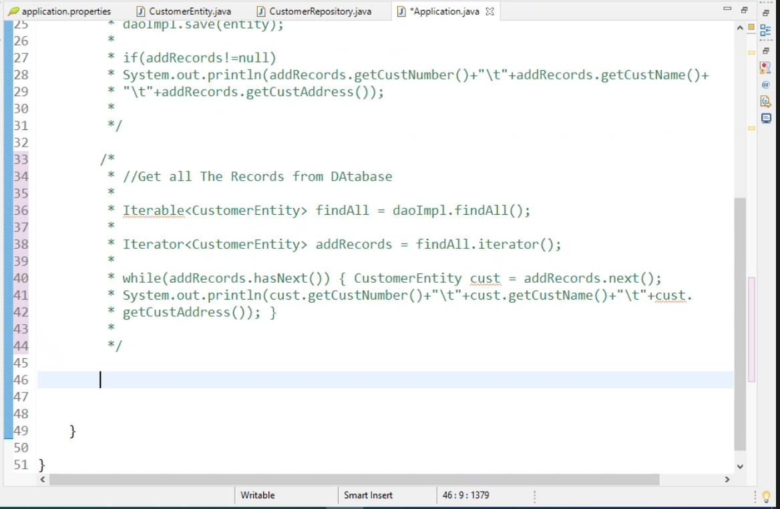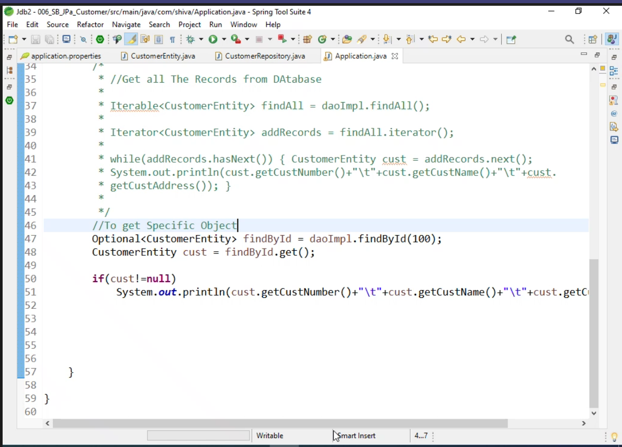

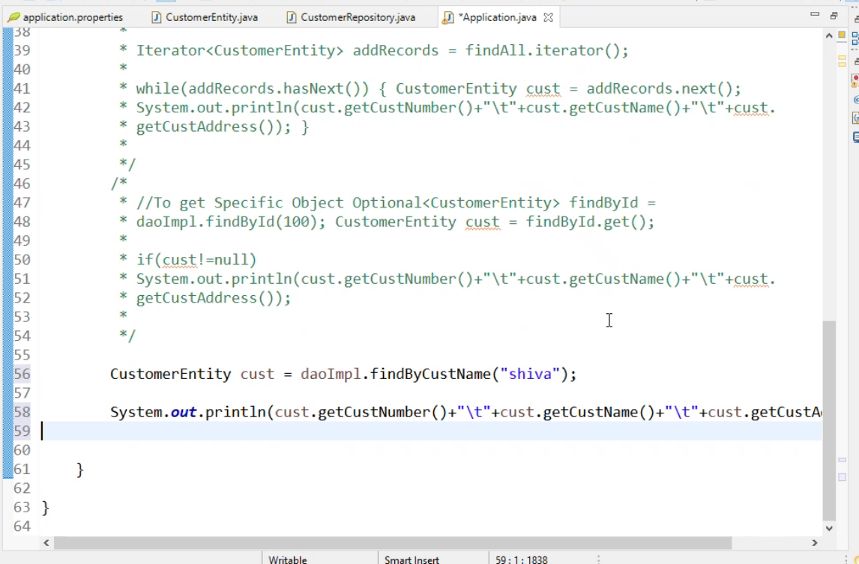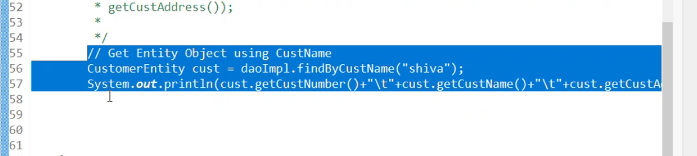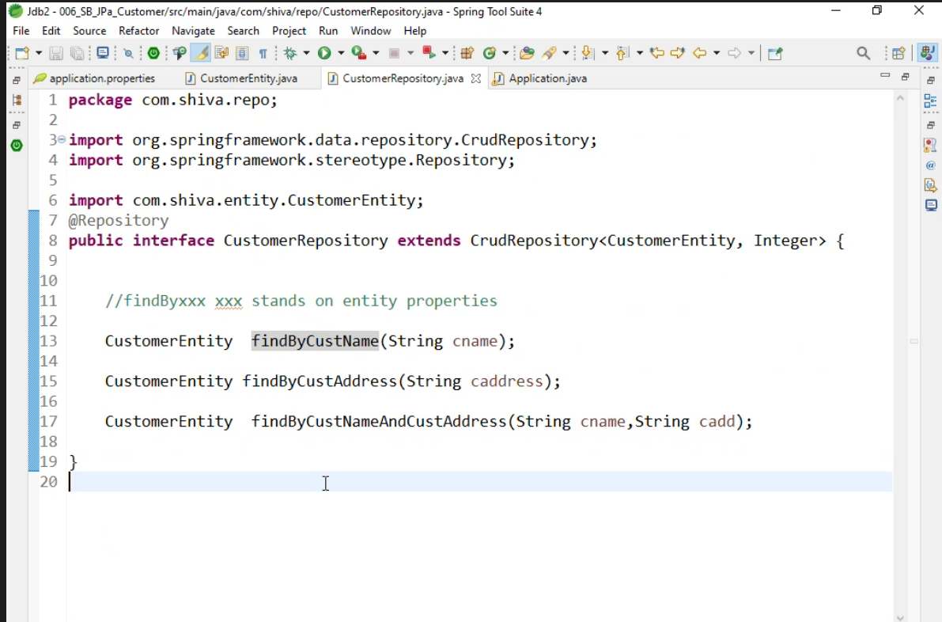

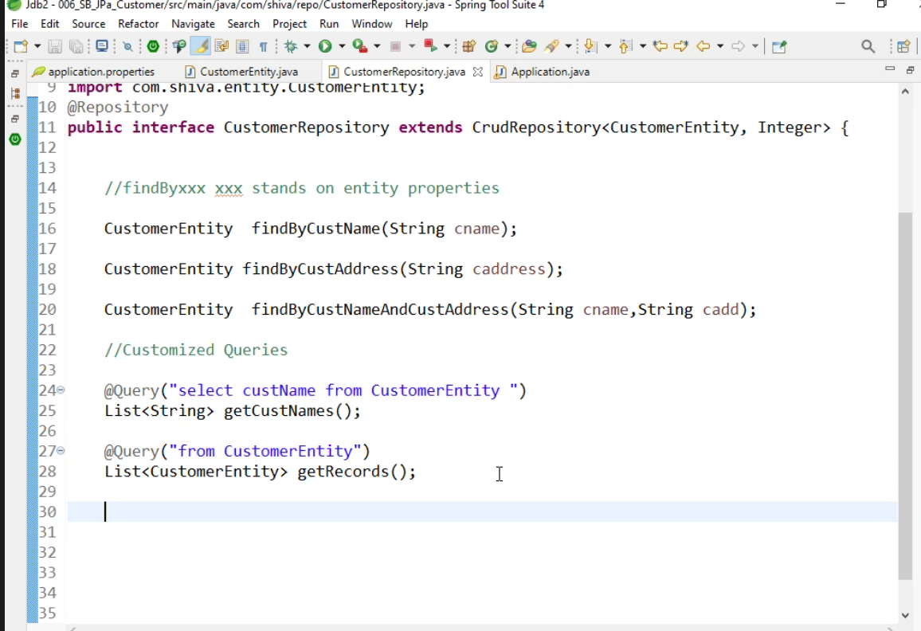

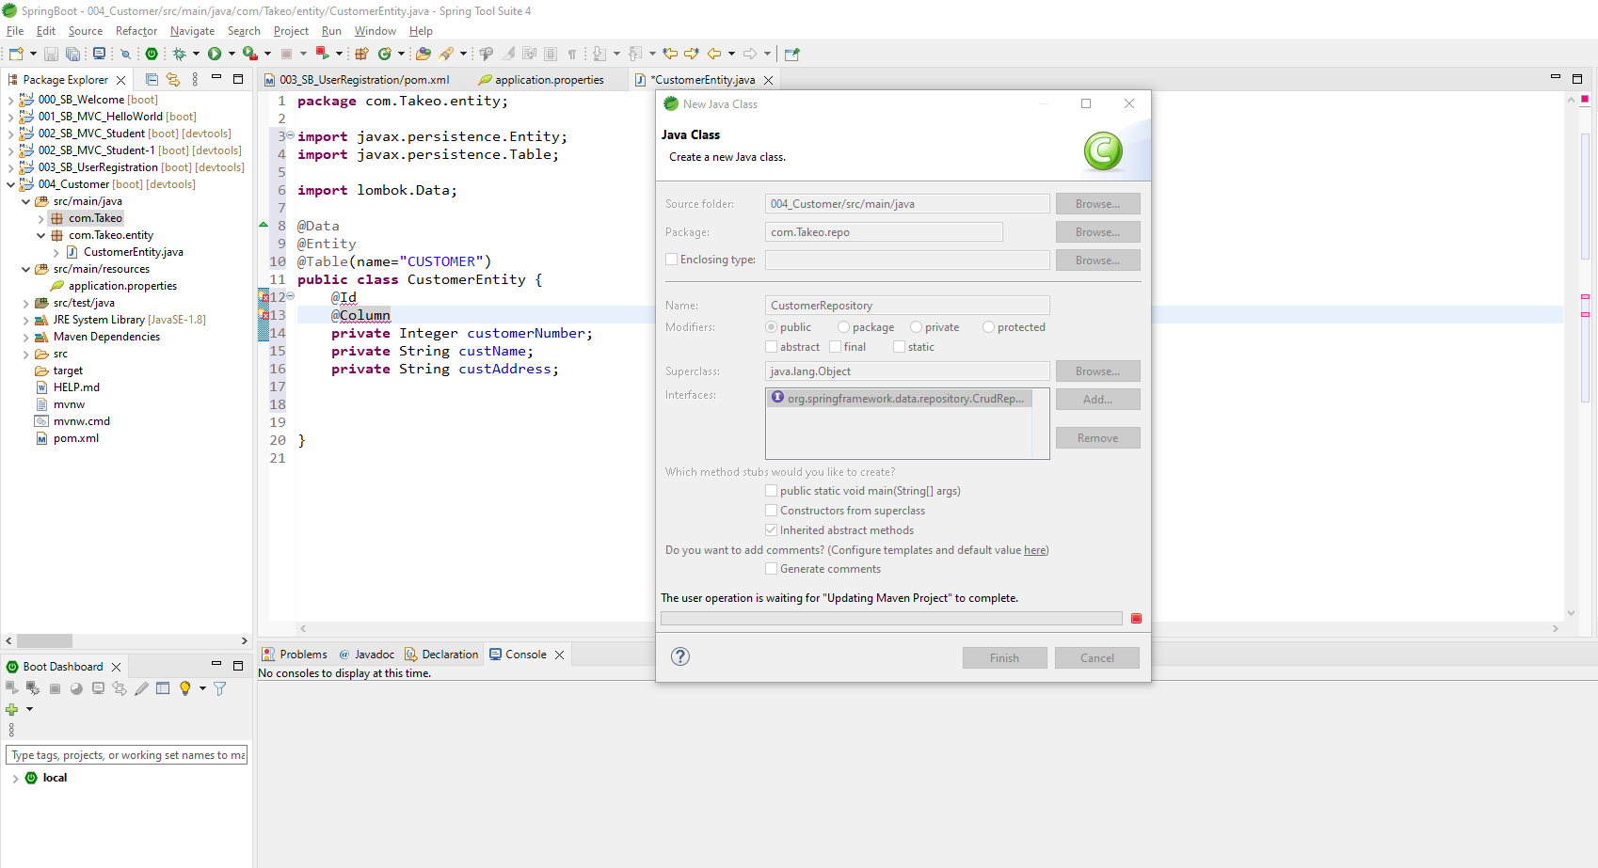

Date: 6/8/2022

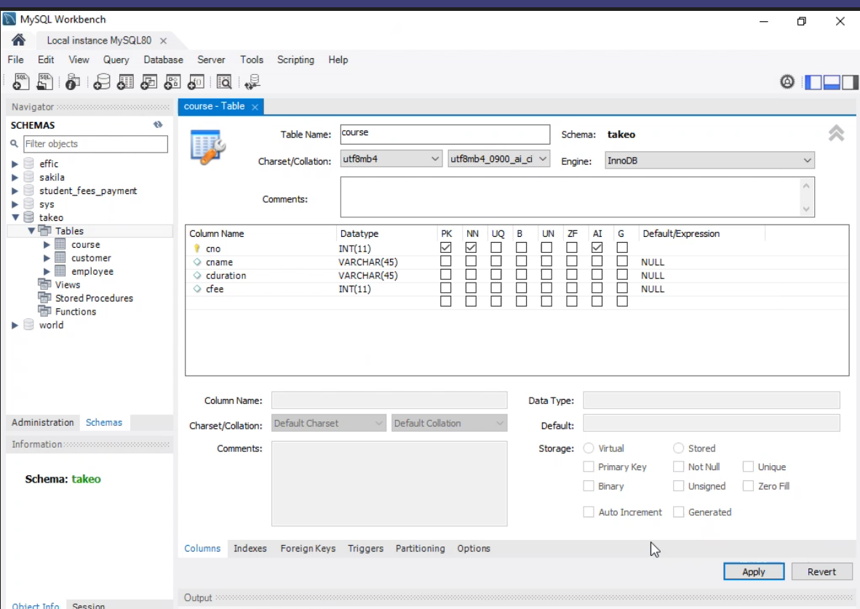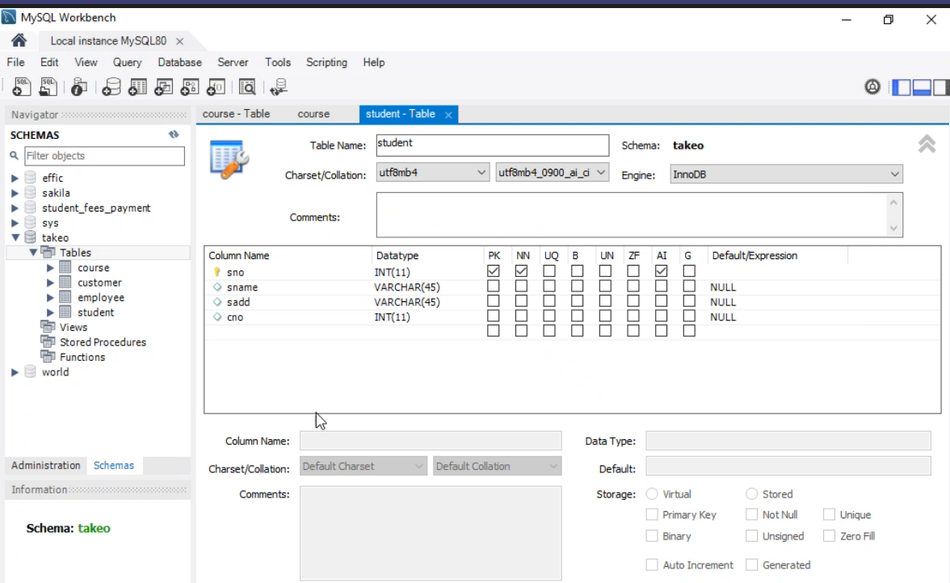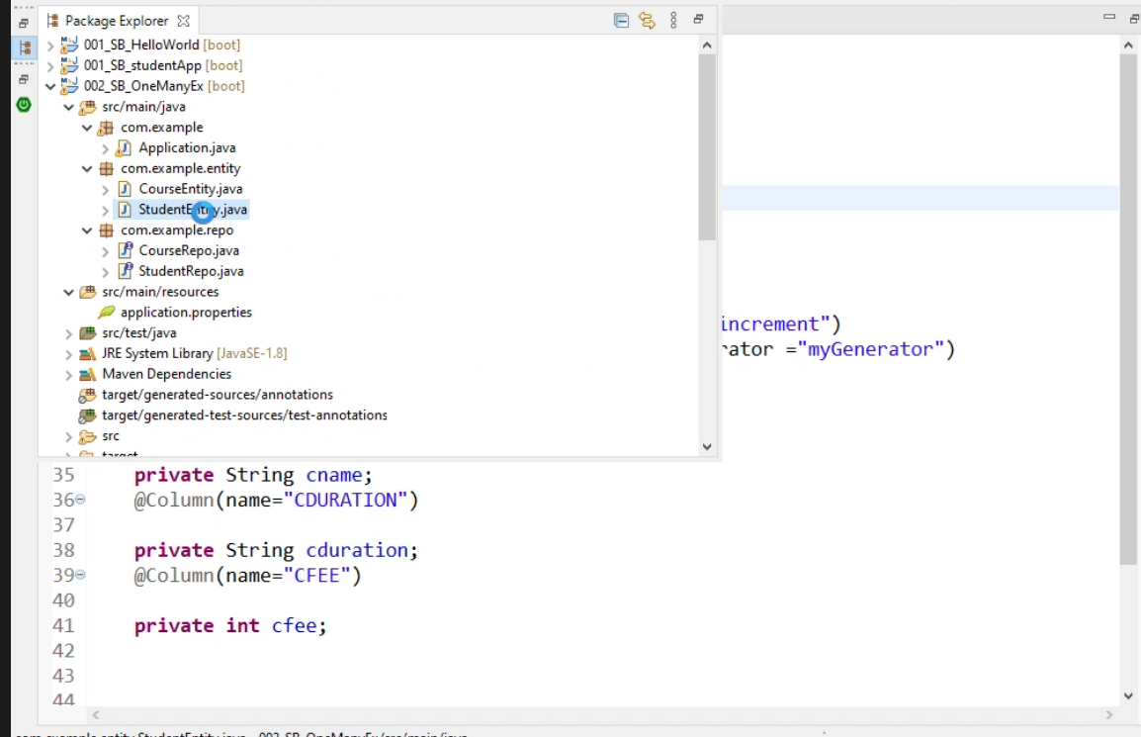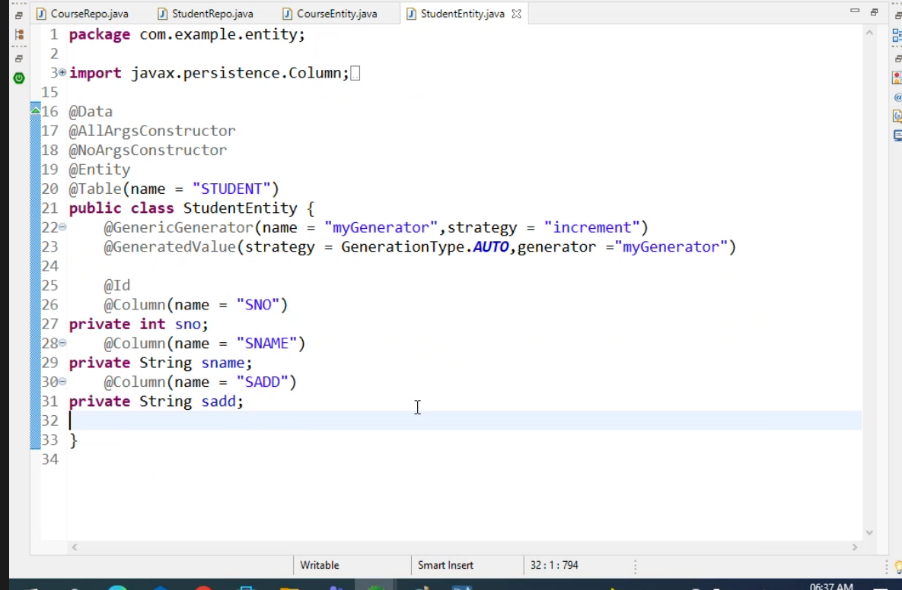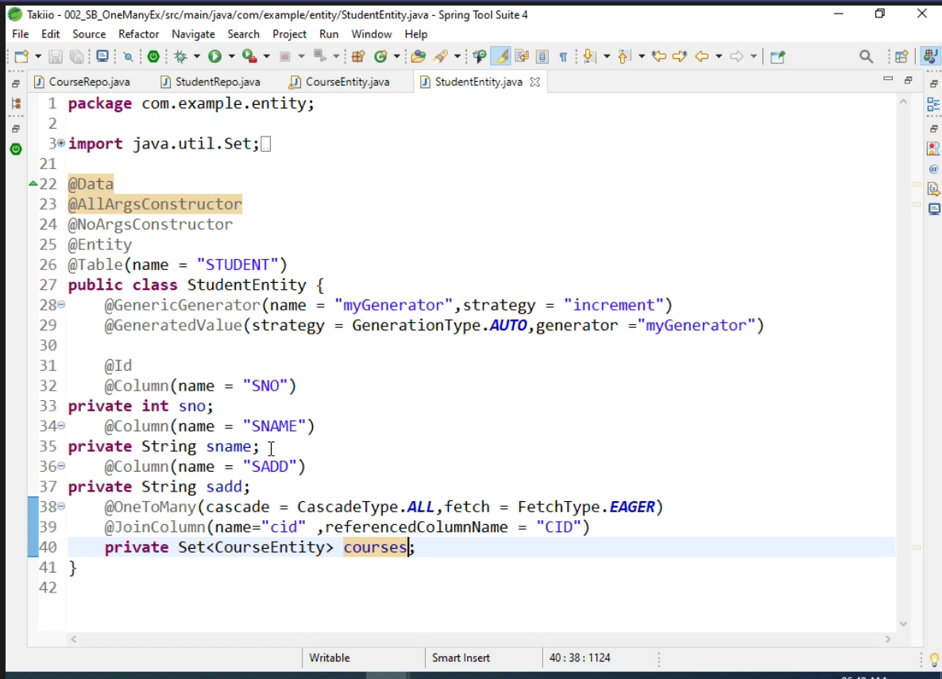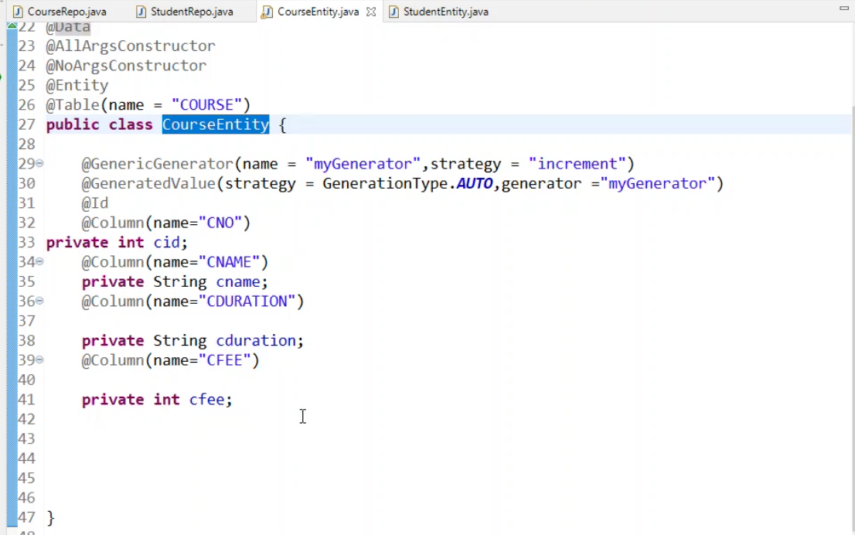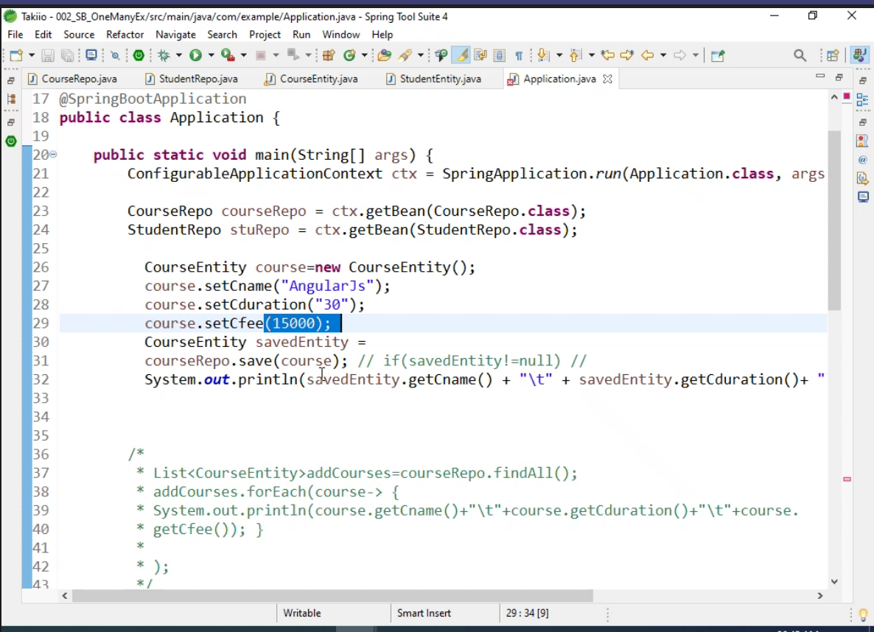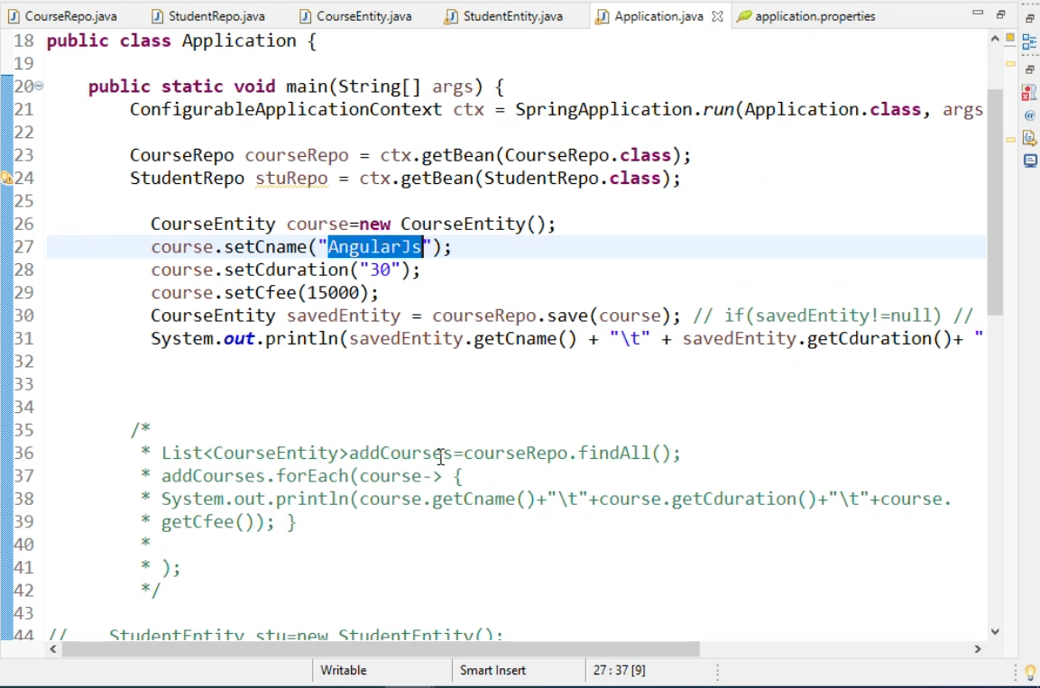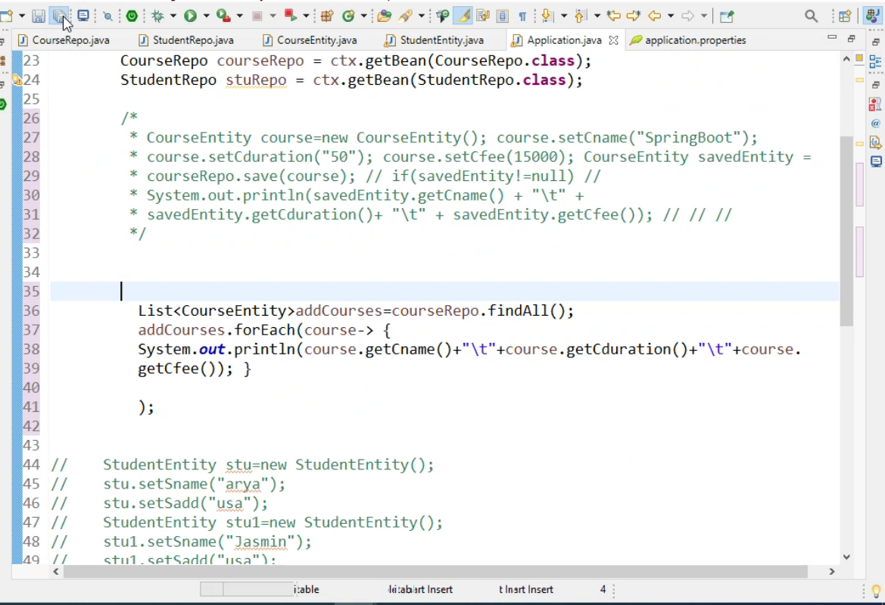

Example: 2

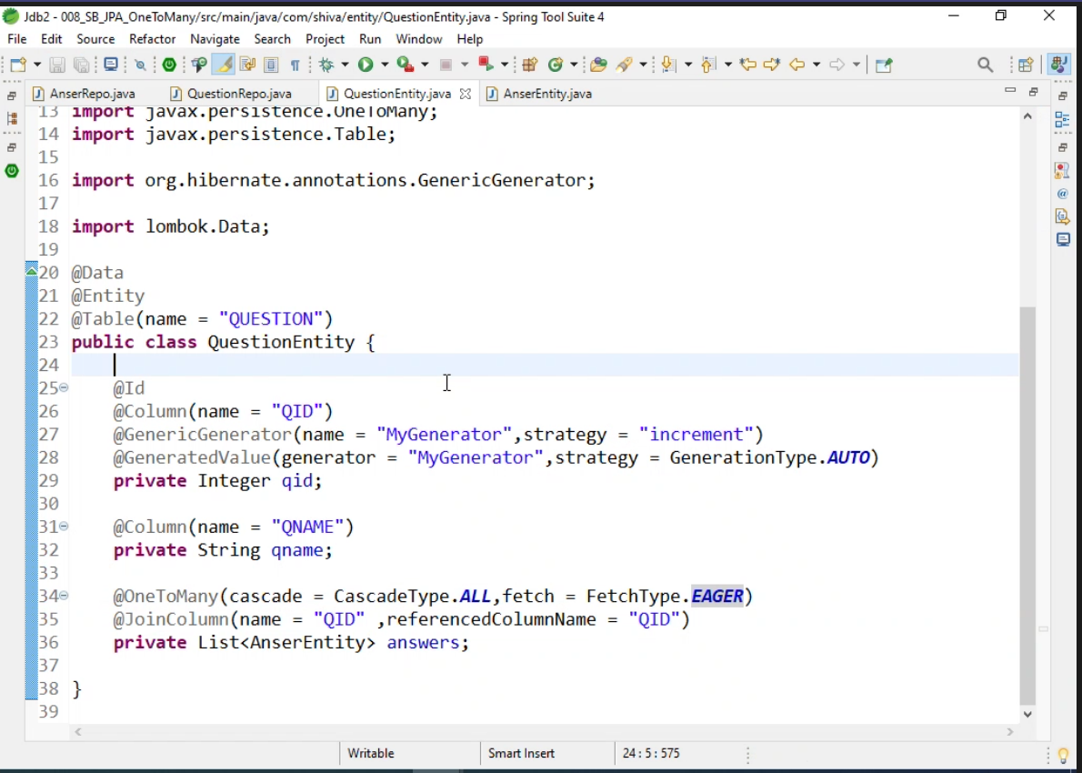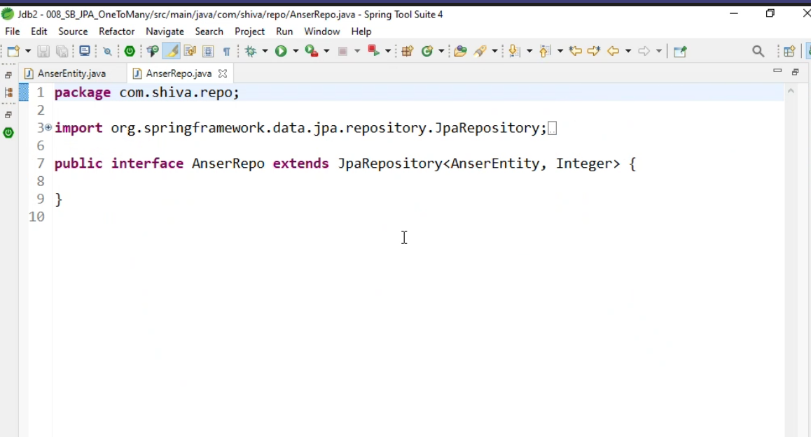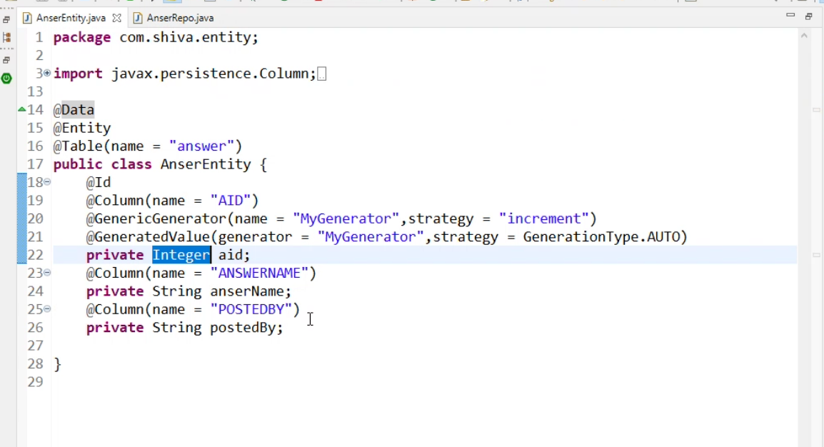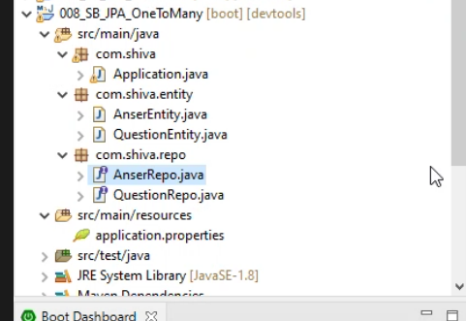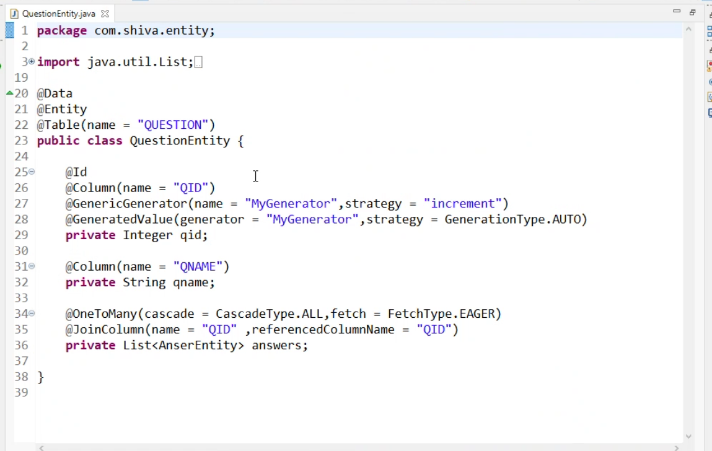

One to Many relationship

1. Create two Tables and set up foreign keys

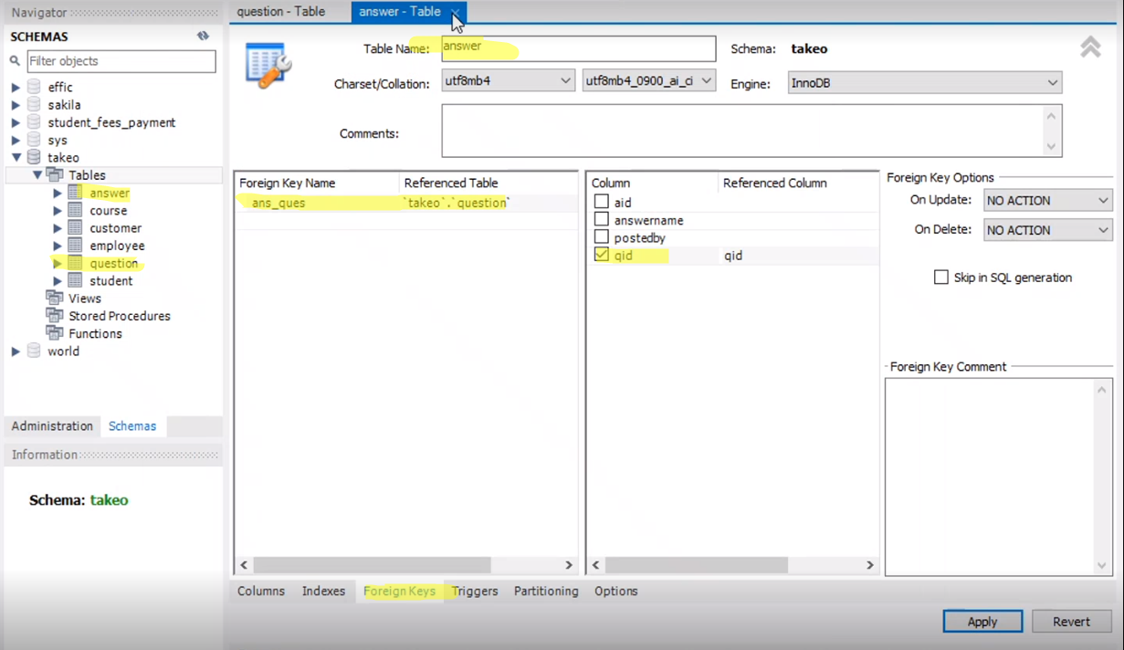

1. Create project staters
2. Add following items.

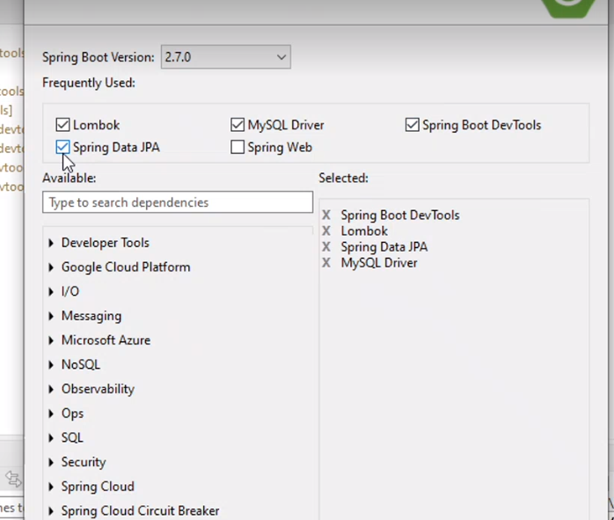

1. Add following item in Applcation.properties
   1. spring.datasource.driver-class-name=com.mysql.cj.jdbc.Driver
   2. spring.datasource.url= jdbc:mysql://localhost:3306/takeo
   3. spring.datasource.username=root
   4. spring.datasource.password=root
   5. spring.jpa.show-sql=true

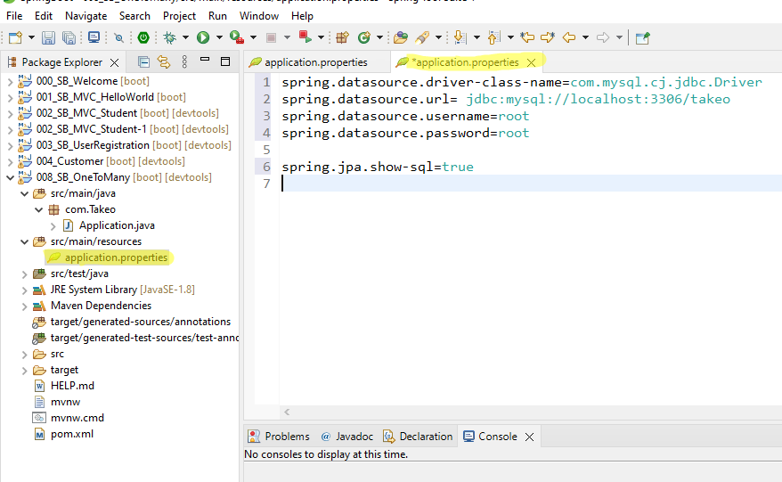

1. create repo.

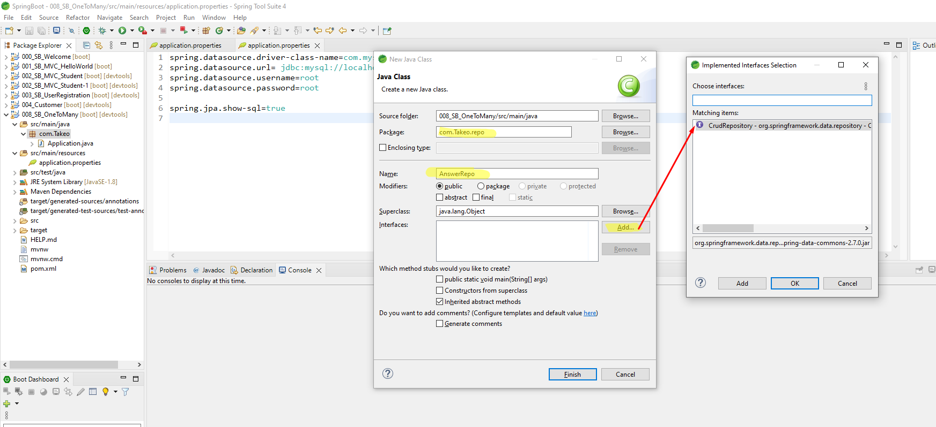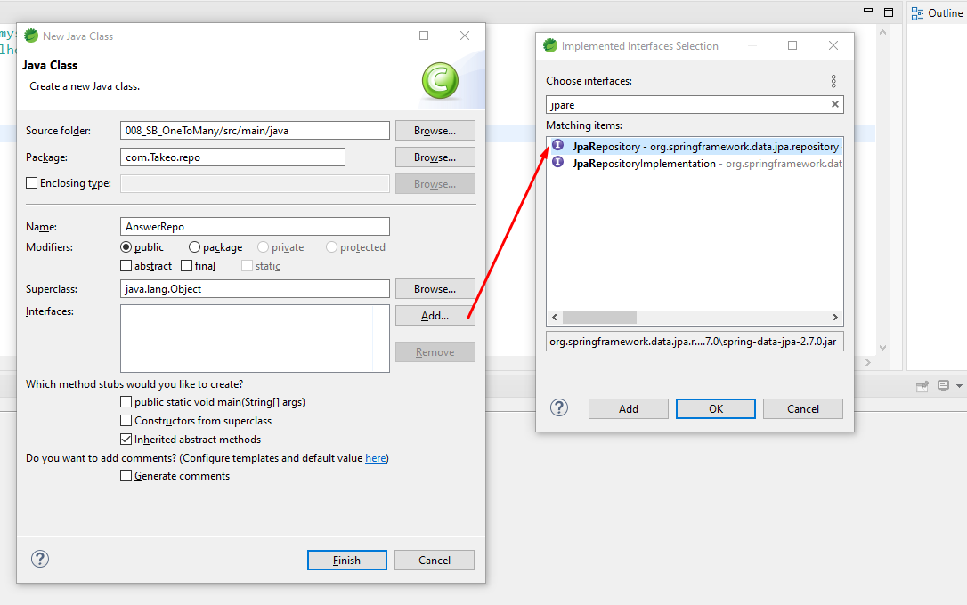

1. Create QuestionRepo with interface

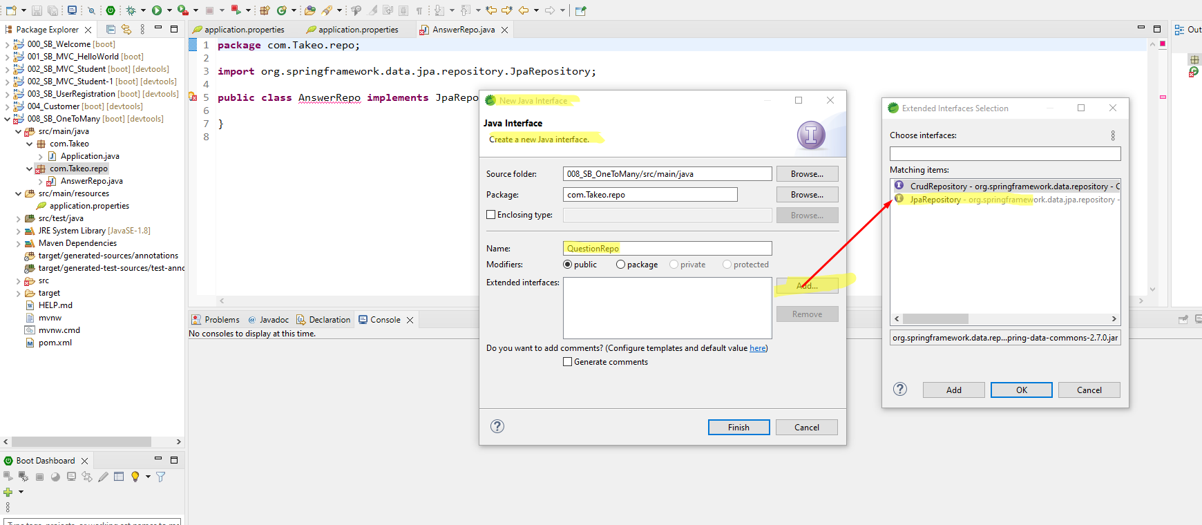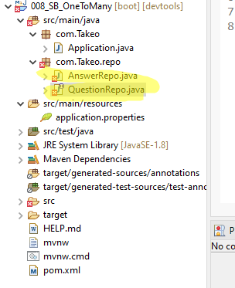

1. Create Question and Answer entity

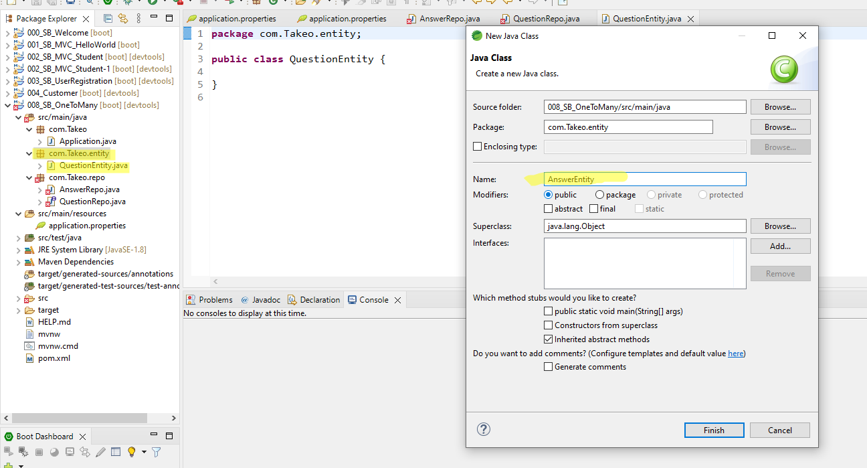

1. Set up Question entity to question repo and answer to answer repo

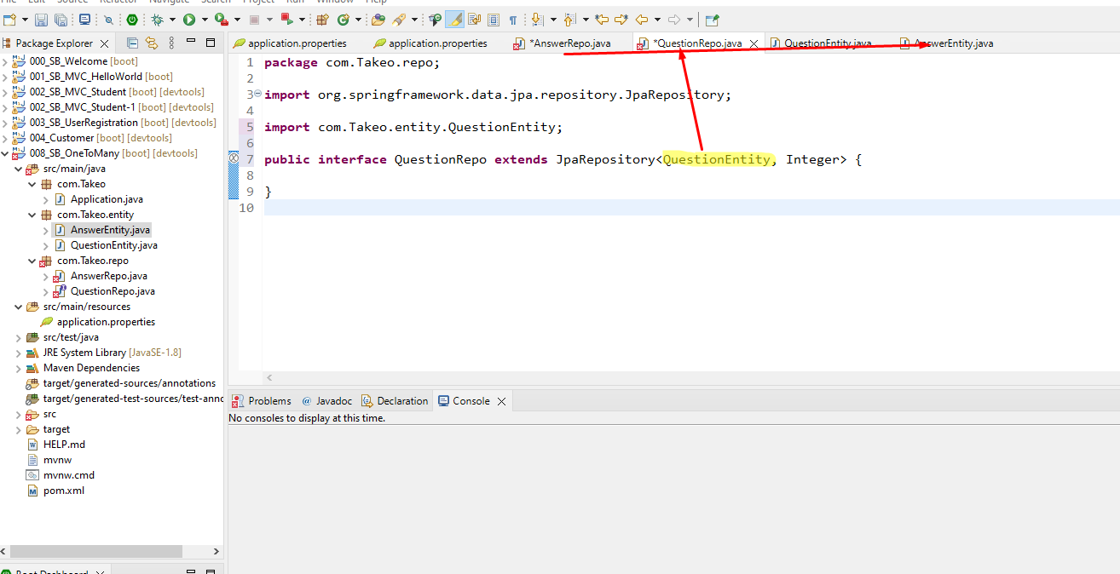

1. Set up GenericGenerator in Question Entity.

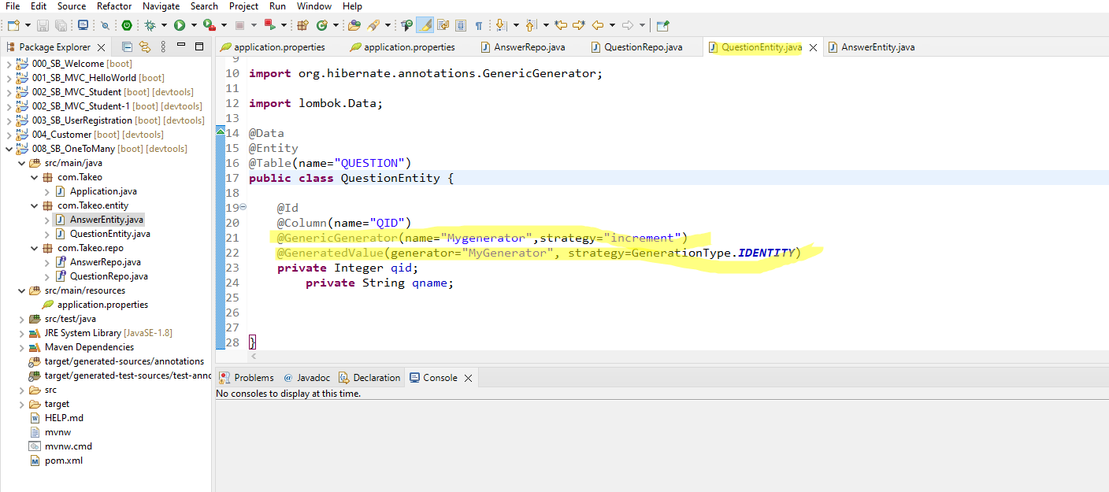

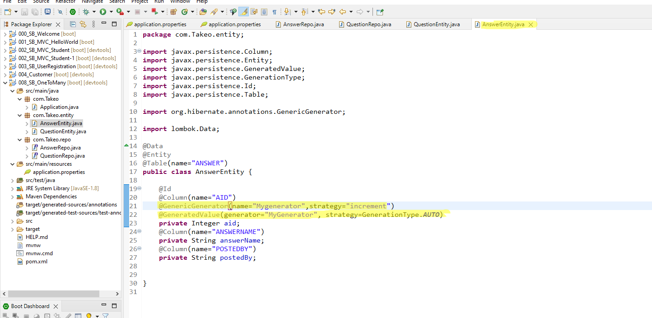

1. Set up relationships with other table

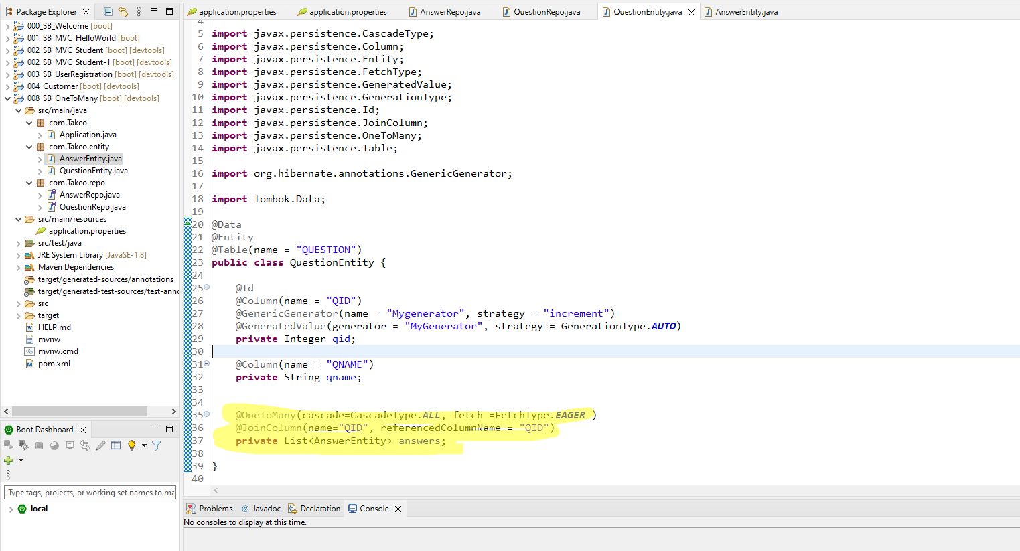

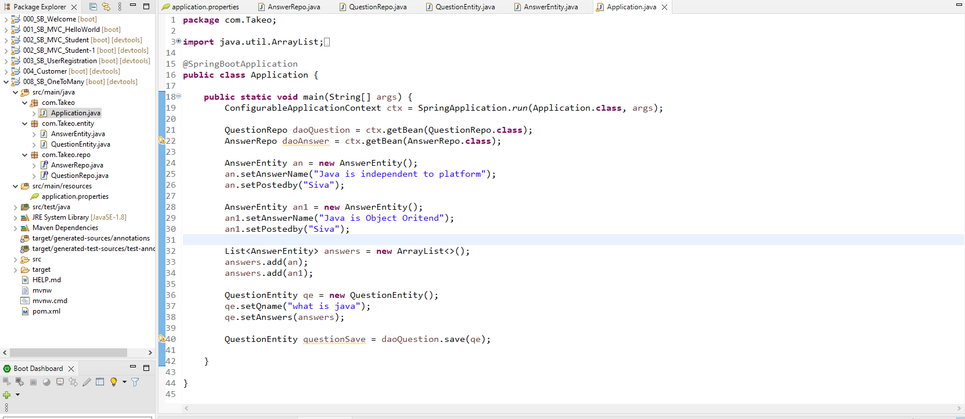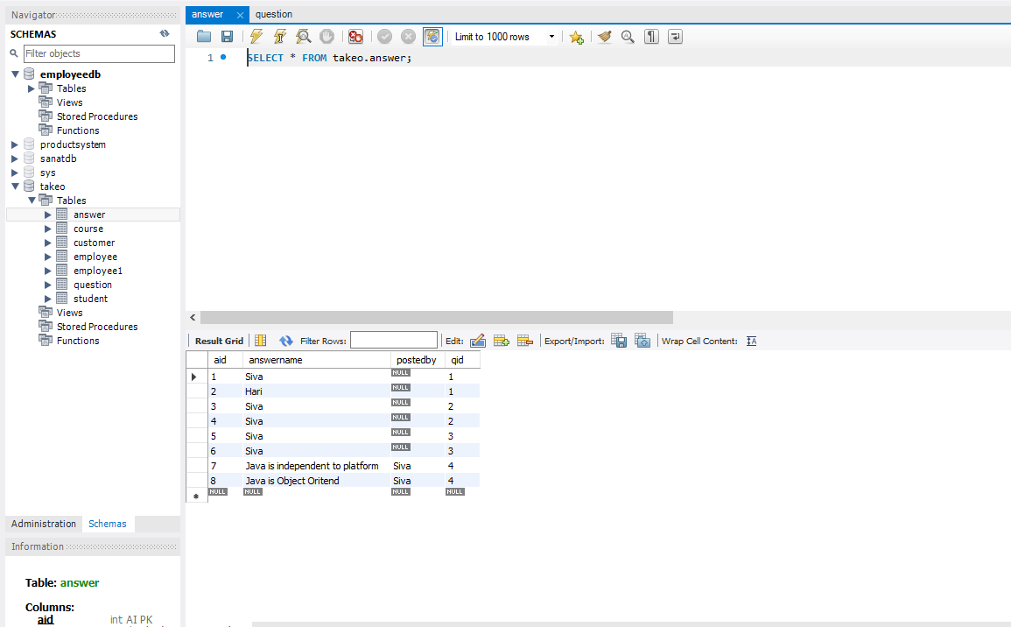

Many to One, One to Many

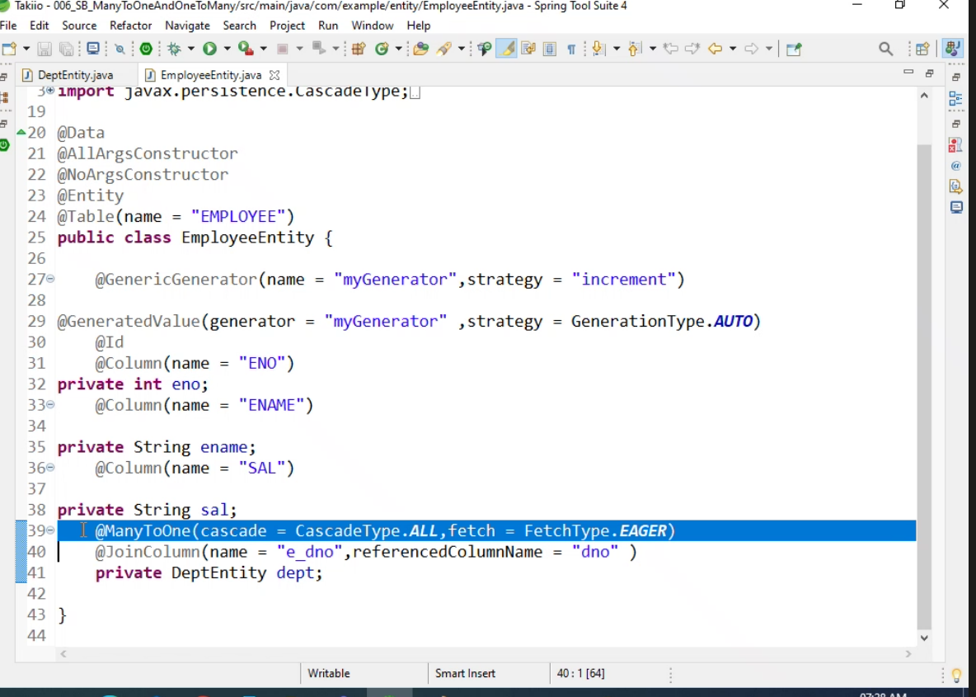

E2E Project Example

Step 1. Create project with following dependency.

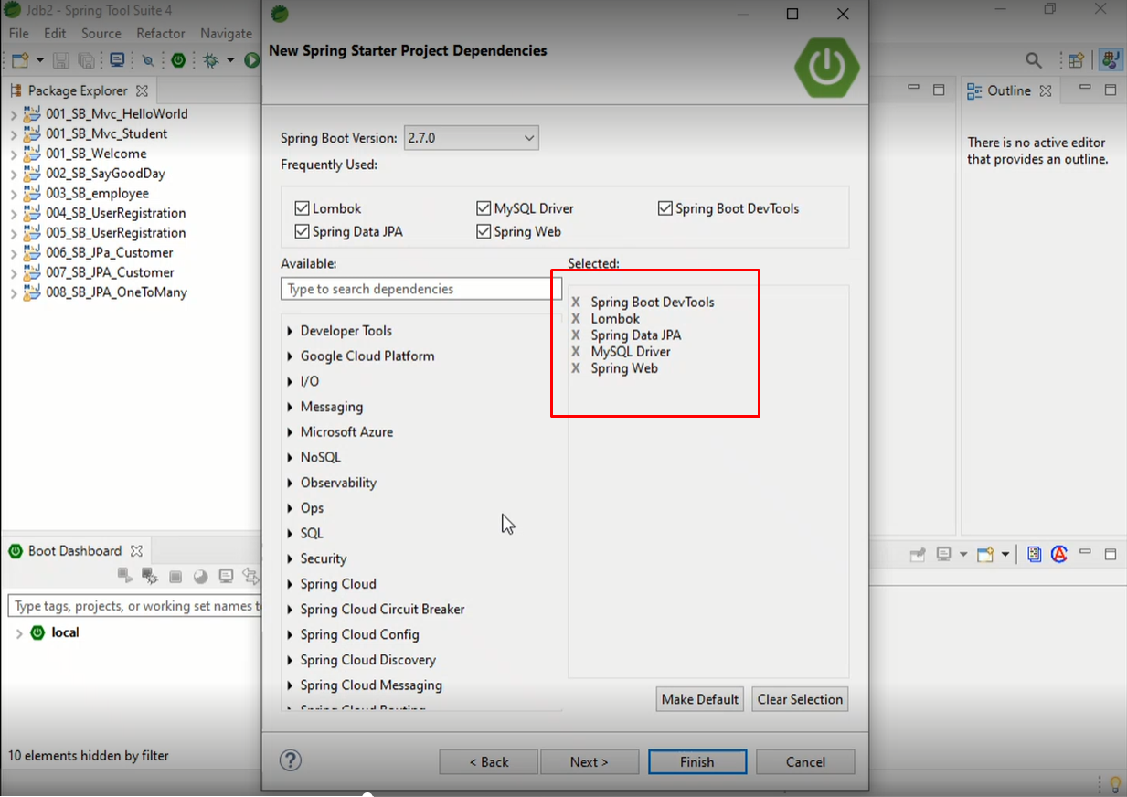

Step 2. Create a table “employee”

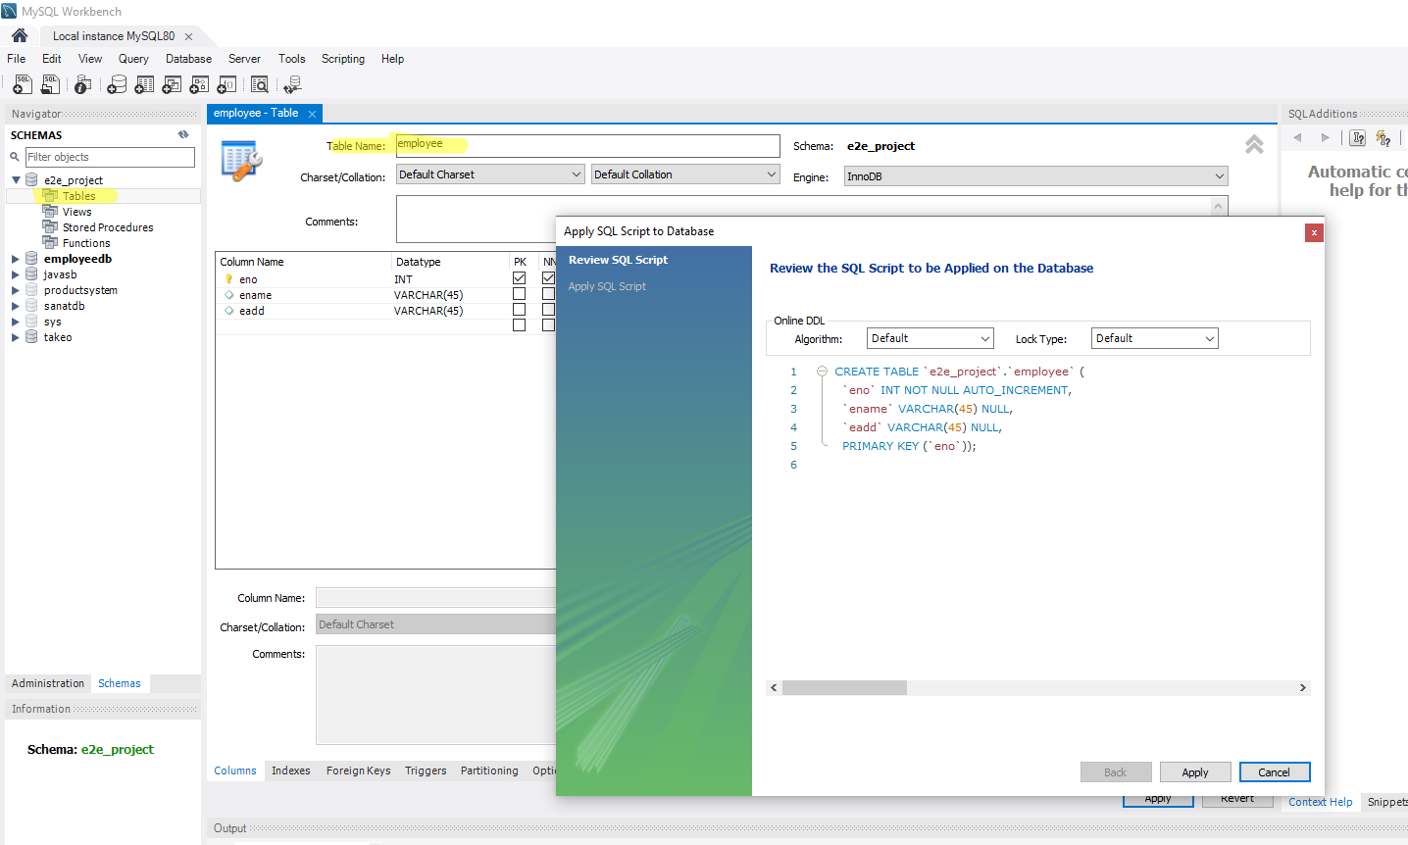

Step 4: Create a Entity package and Class [ EmployeeEntity]

* Entity class which link with Database class

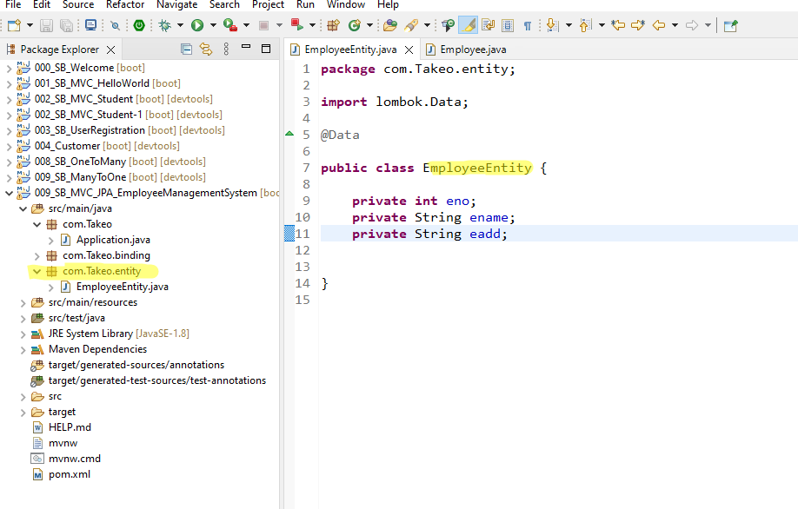

Step 5: Create a Binding class. Which is springmvcform tags.

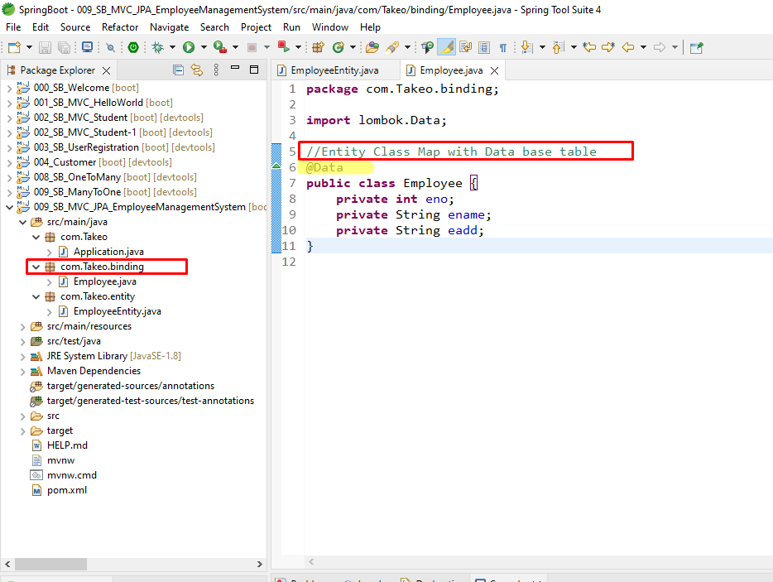

Step 6: Update EmployeeEntity Class with Data, entity

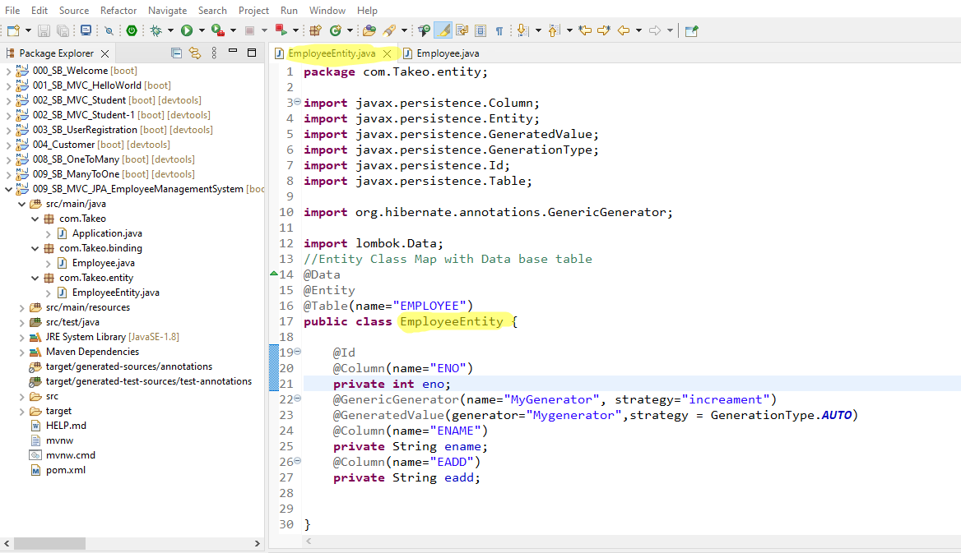

Step 7: Set up Configuration file [ Data base connection and Spring MVC file]

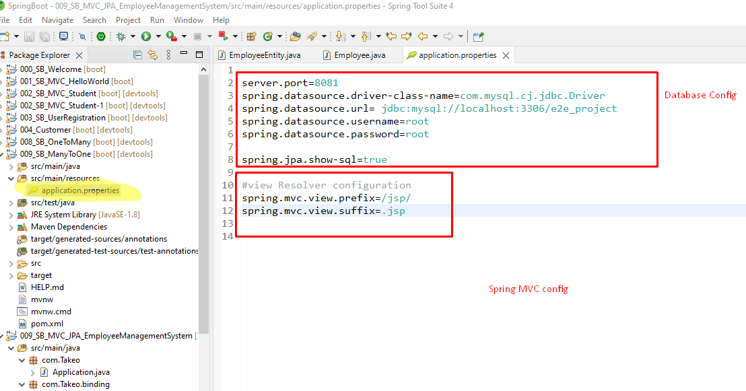

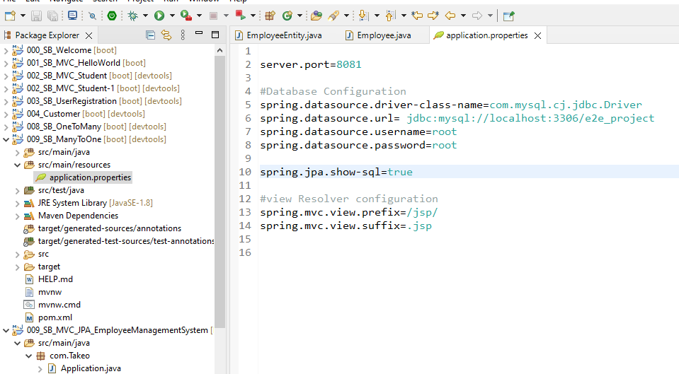

Step 8: Create a Employee Repository package, create interface and extend the JPS

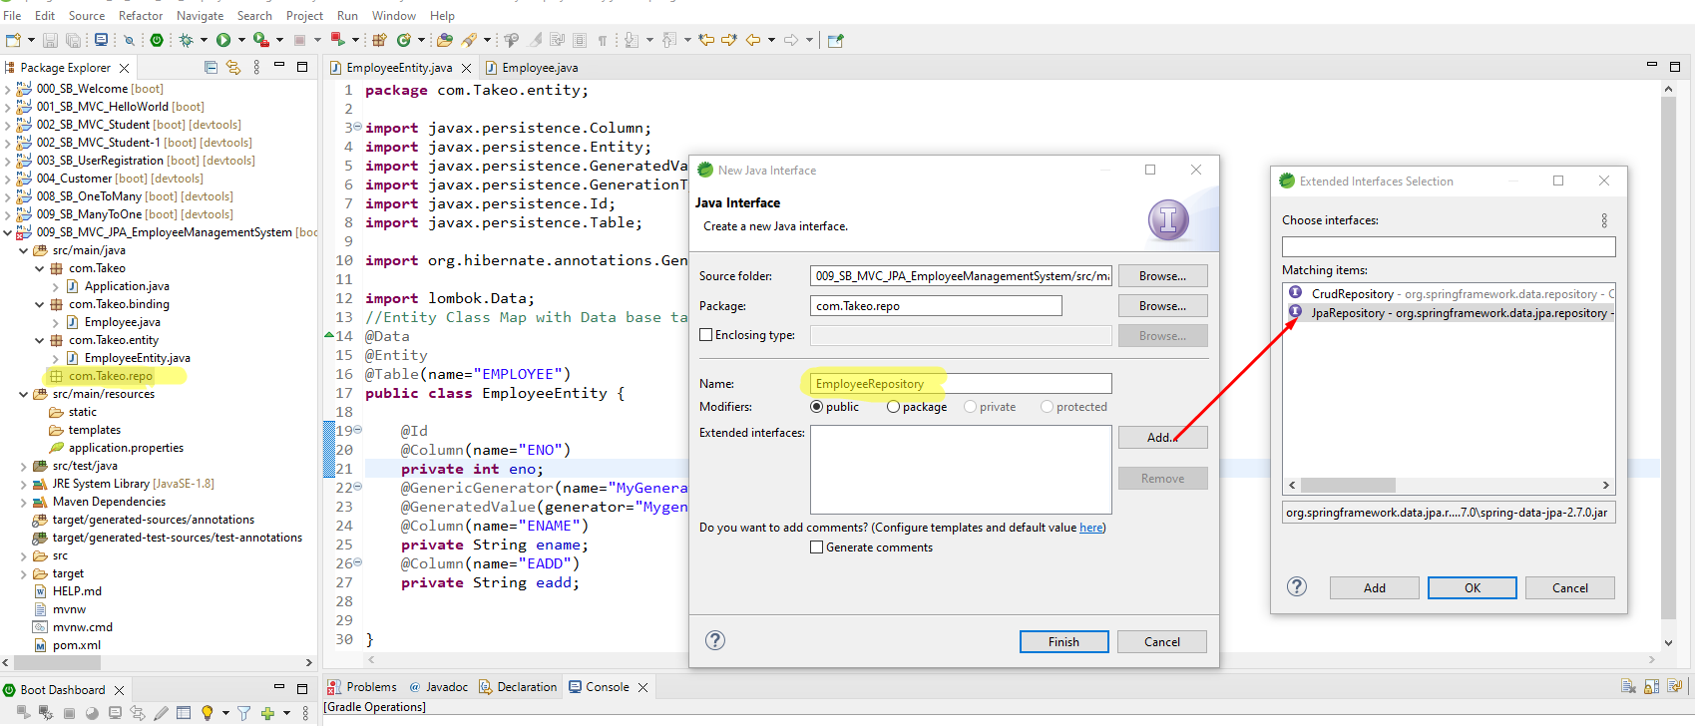

Step 9, Configure Entity class and Add annotation (@Repository)

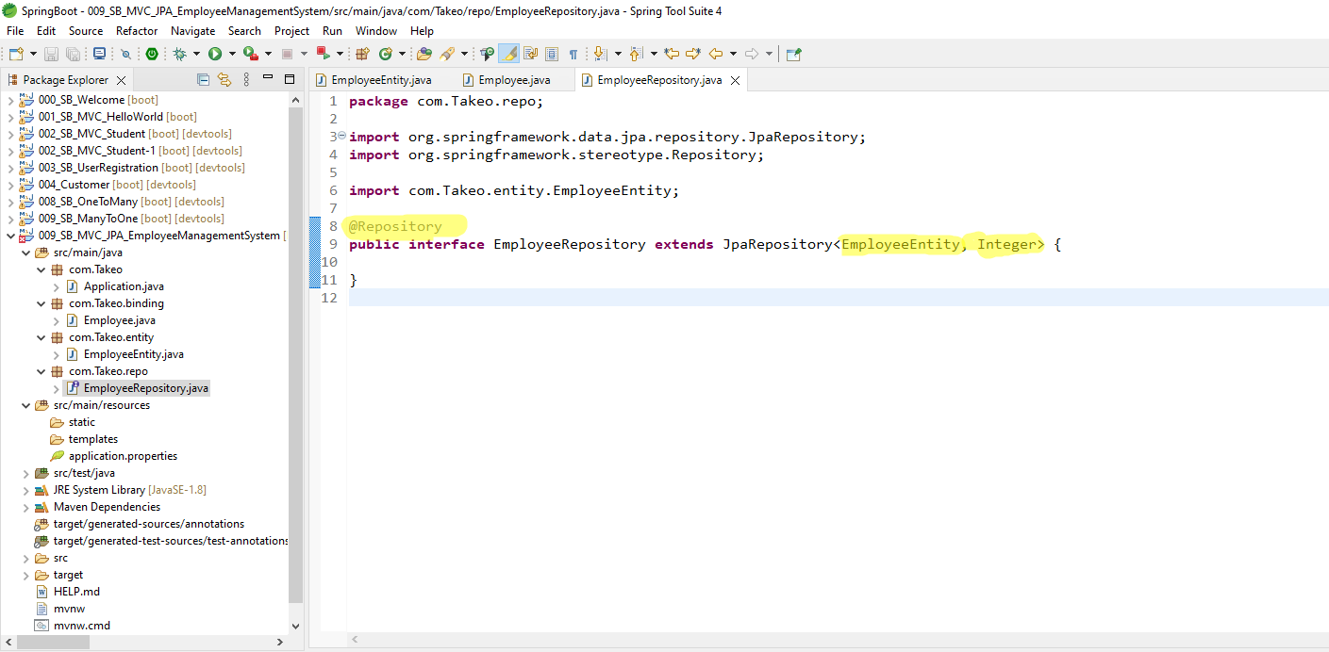

Step 11: Create a new package and Employee service

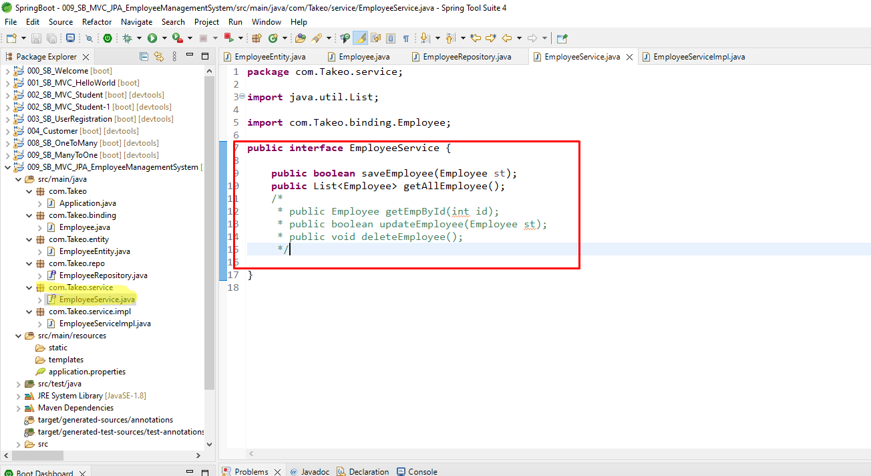

Step 10, Create a class with Implementation [ EmployeeServieIMPL] and extend the Employee service class

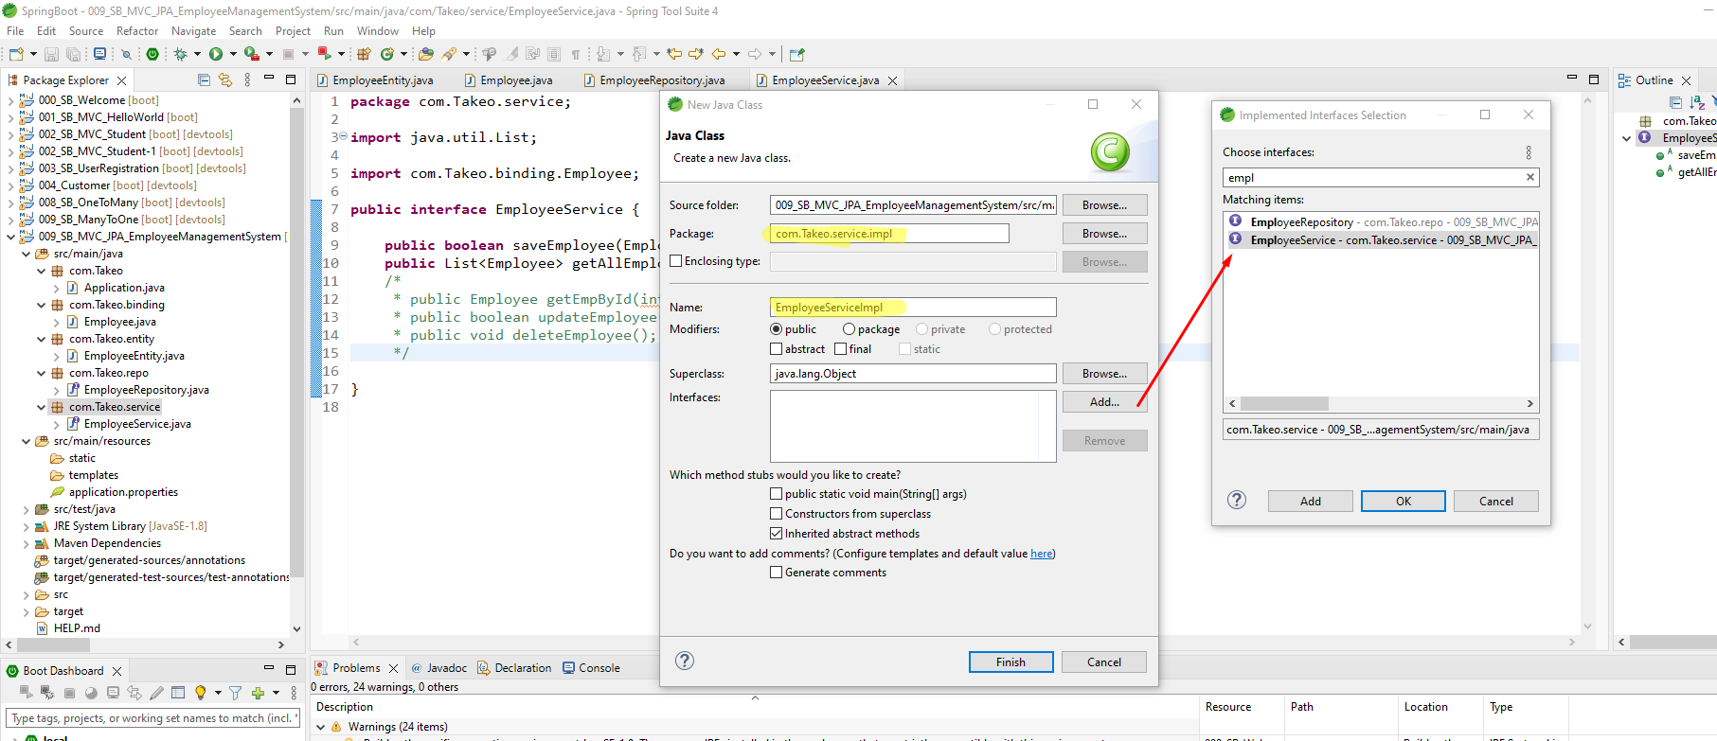

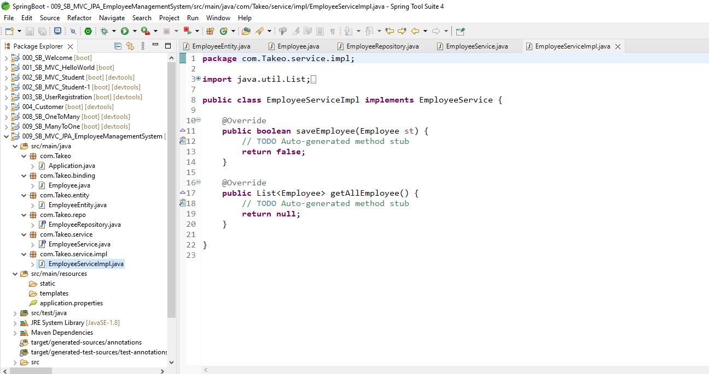

Step 13: Create EmployeeServiceImpl to implement the method, and tranfer data from SpringMVC form to data base via Servic

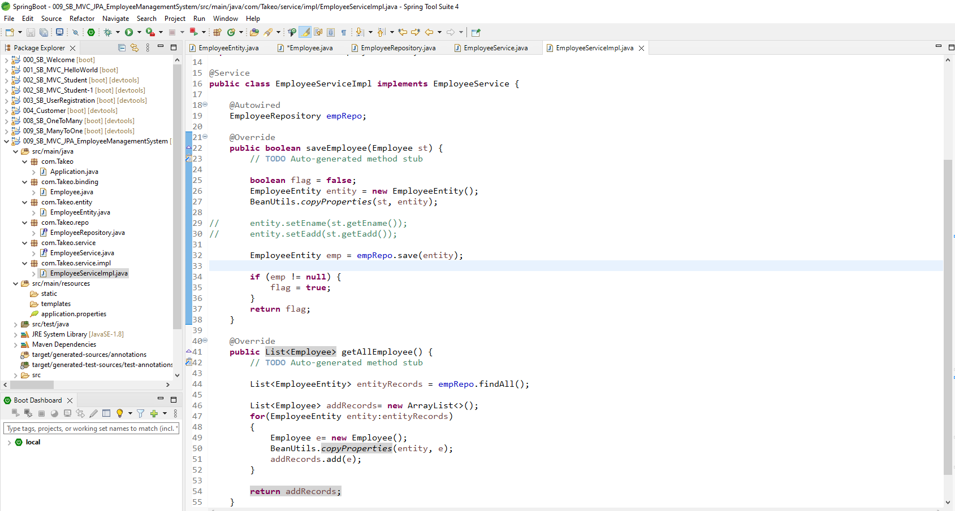

**package** com.Takeo.service.impl;

**import** java.util.ArrayList;

**import** java.util.List;

**import** org.springframework.beans.BeanUtils;

**import** org.springframework.beans.factory.annotation.Autowired;

**import** org.springframework.stereotype.Service;

**import** com.Takeo.binding.Employee;

**import** com.Takeo.entity.EmployeeEntity;

**import** com.Takeo.repo.EmployeeRepository;

**import** com.Takeo.service.EmployeeService;

@Service

**public** **class** EmployeeServiceImpl **implements** EmployeeService {

@Autowired

EmployeeRepository empRepo;

@Override

**public** **boolean** saveEmployee(Employee st) {

// **TODO** Auto-generated method stub

**boolean** flag = **false**;

EmployeeEntity entity = **new** EmployeeEntity();

BeanUtils.*copyProperties*(st, entity);

// entity.setEname(st.getEname());

// entity.setEadd(st.getEadd());

EmployeeEntity emp = empRepo.save(entity);

**if** (emp != **null**) {

flag = **true**;

}

**return** flag;

}

@Override

**public** List<Employee> getAllEmployee() {

// **TODO** Auto-generated method stub

List<EmployeeEntity> entityRecords = empRepo.findAll();

List<Employee> addRecords= **new** ArrayList<>();

**for**(EmployeeEntity entity:entityRecords)

{

Employee e= **new** Employee();

BeanUtils.*copyProperties*(entity, e);

addRecords.add(e);

}

**return** addRecords;

}

}

Step 14: create Controller class and package.

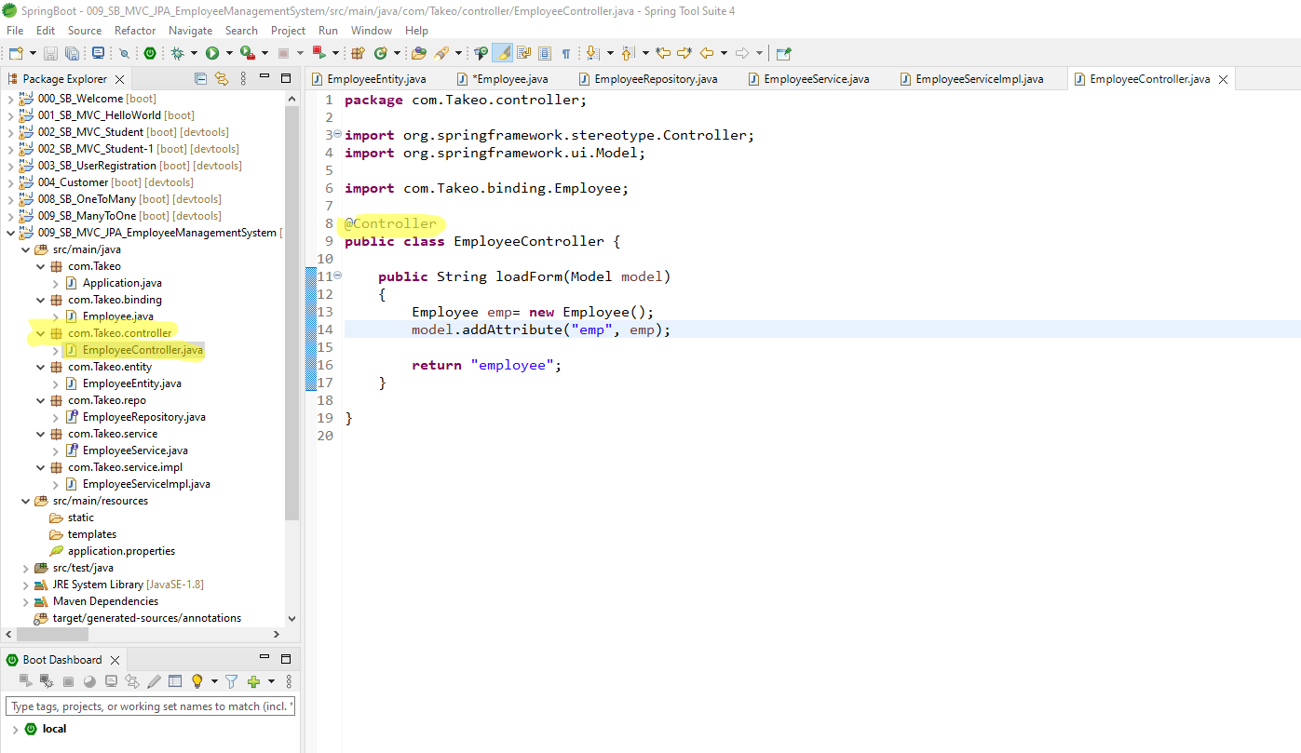

Step 14: Create JSP file and set up the form as follows:

Create Webapp folder and Jsp sub folder under src folder in the project.

Create jsp file [employee.jsp]

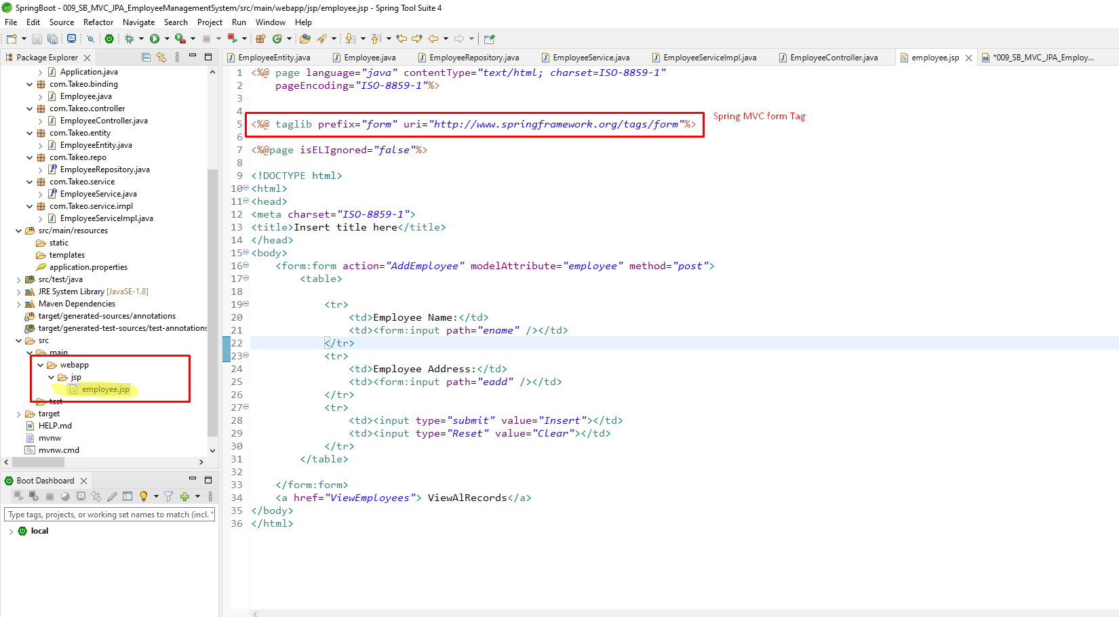

Step 15: add Depandancey for Tomcat

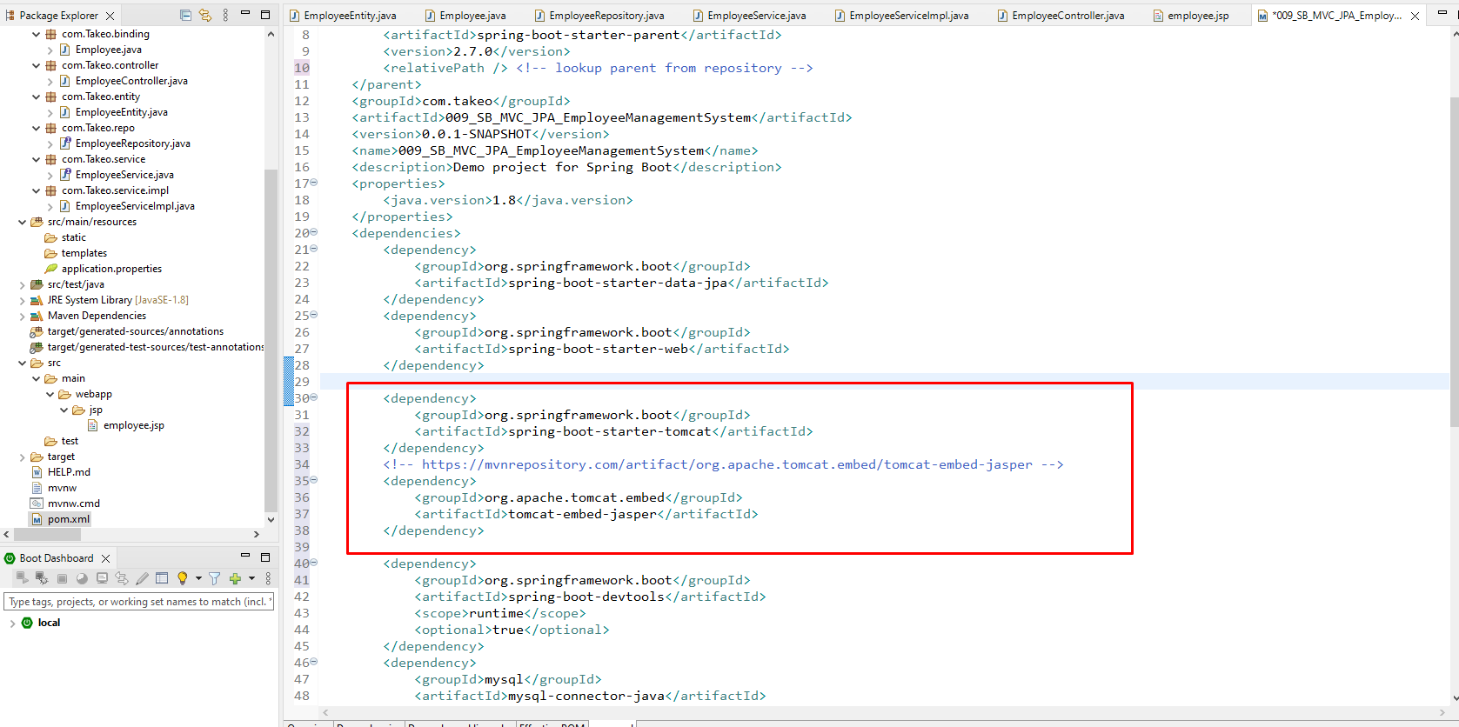

Step 16: Add request mapping under Controller [Employee Controller]

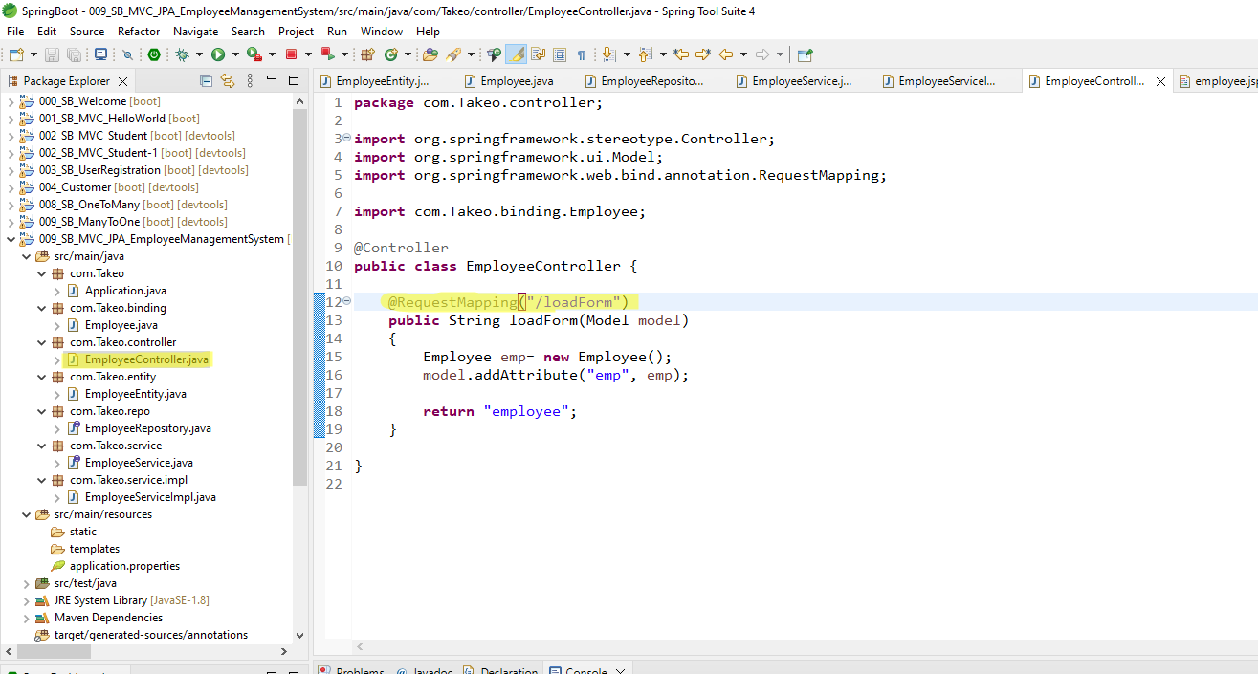

Step 17. Set up message in webpage

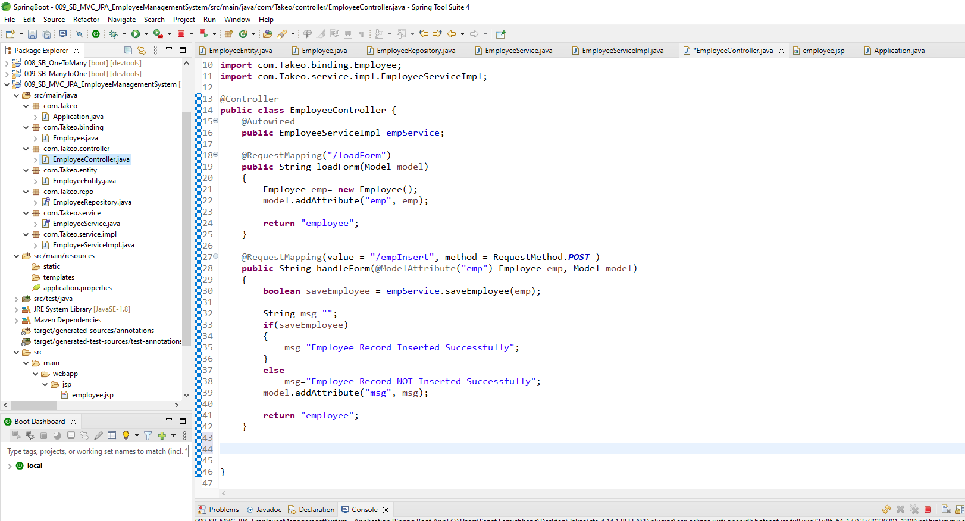

Step 18: add another jsp page to view all the employees: [View Employee.jps][

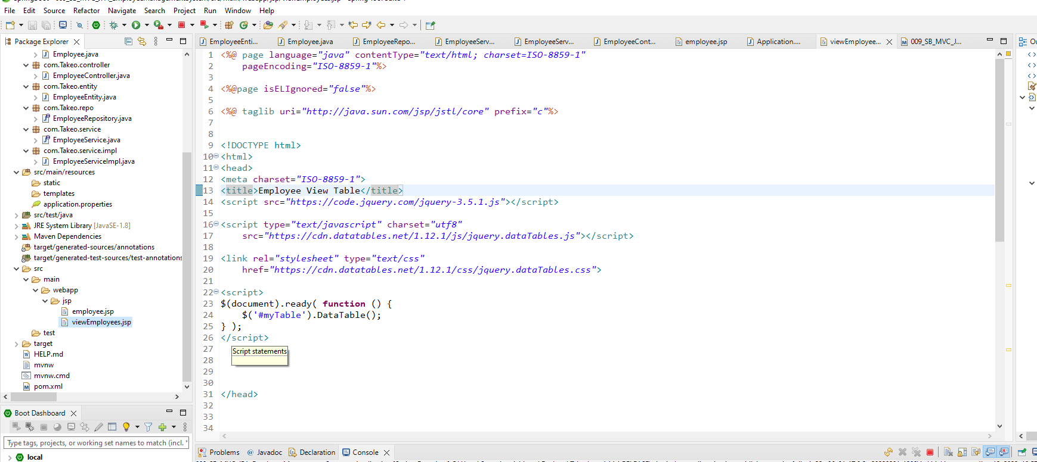

<%@ page language=*"java"* contentType=*"text/html; charset=ISO-8859-1"*

pageEncoding=*"ISO-8859-1"*%>

<%@page isELIgnored=*"false"*%>

<%@ taglib uri=*"http://java.sun.com/jsp/jstl/core"* prefix=*"c"*%>

<!DOCTYPE html>

<html>

<head>

<meta charset=*"ISO-8859-1"*>

<title>Employee View Table</title>

<script src=*"https://code.jquery.com/jquery-3.5.1.js"*></script>

<script type=*"text/javascript"* charset=*"utf8"*

src=*"https://cdn.datatables.net/1.12.1/js/jquery.dataTables.js"*></script>

<link rel=*"stylesheet"* type=*"text/css"*

href=*"https://cdn.datatables.net/1.12.1/css/jquery.dataTables.css"*>

<script>

$(document).ready(**function**() {

$('#myTable').DataTable();

});

</script>

</head>

<body>

<H3>List of all the Employees</H3>

<a href=*"loadForm"*>Add a New Employee</a>

<table border=*"2"* id=*"myTable"*>

<thead>

<tr>

<th>Employee Number</th>

<th>Employee Name</th>

<th>Employee Address</th>

<th>Edit</th>

<th>Delete</th>

</tr>

</thead>

<tbody>

<c:forEach items=*"*${employees}*"* var=*"e"*>

<tr>

<td>${e.eno}</td>

<td>${e.ename}</td>

<td>${e.eadd}</td>

<td><a href=*"editemp?id=*${e.eno}*"*>Edit</a></td>

<td><a href=*"deleteemp?id=*${e.eno}*"* onclick="deleteConfirm()">Delete</a>

</tr>

</c:forEach>

</tbody>

</table>

</body>

</html>

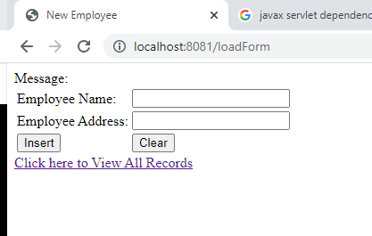

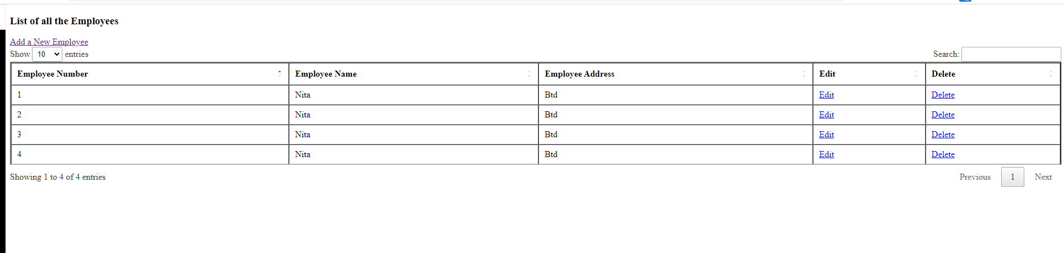

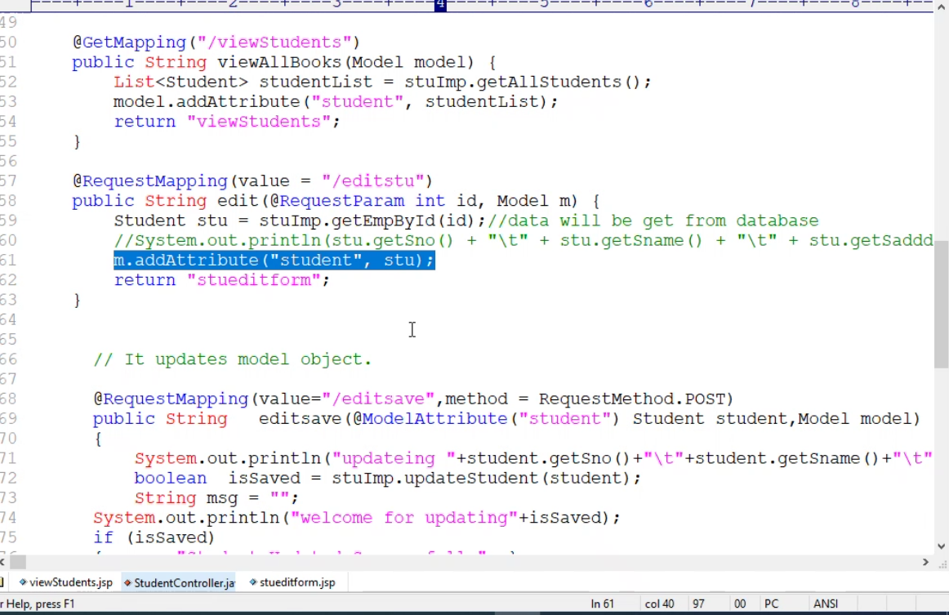 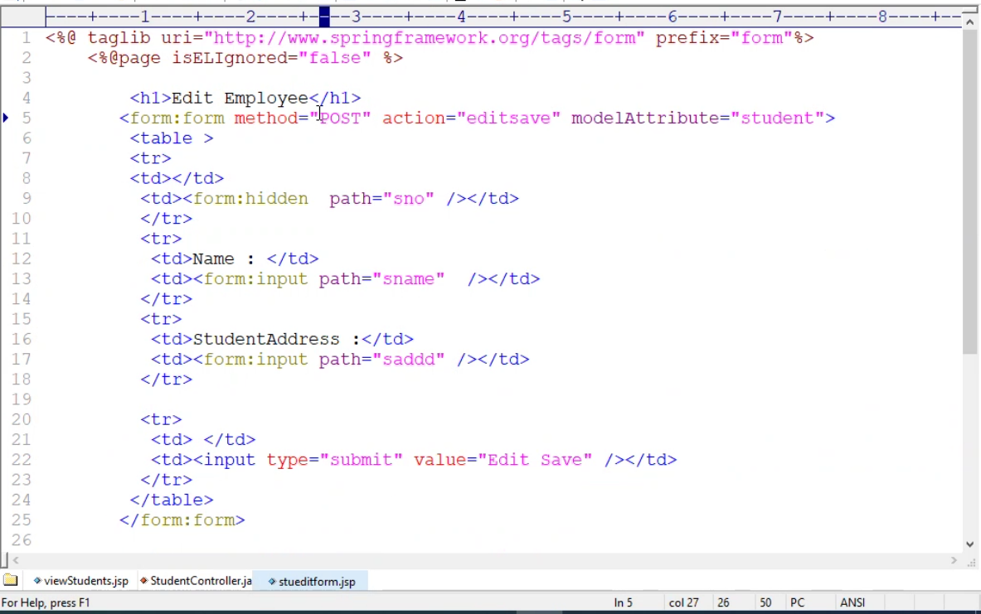 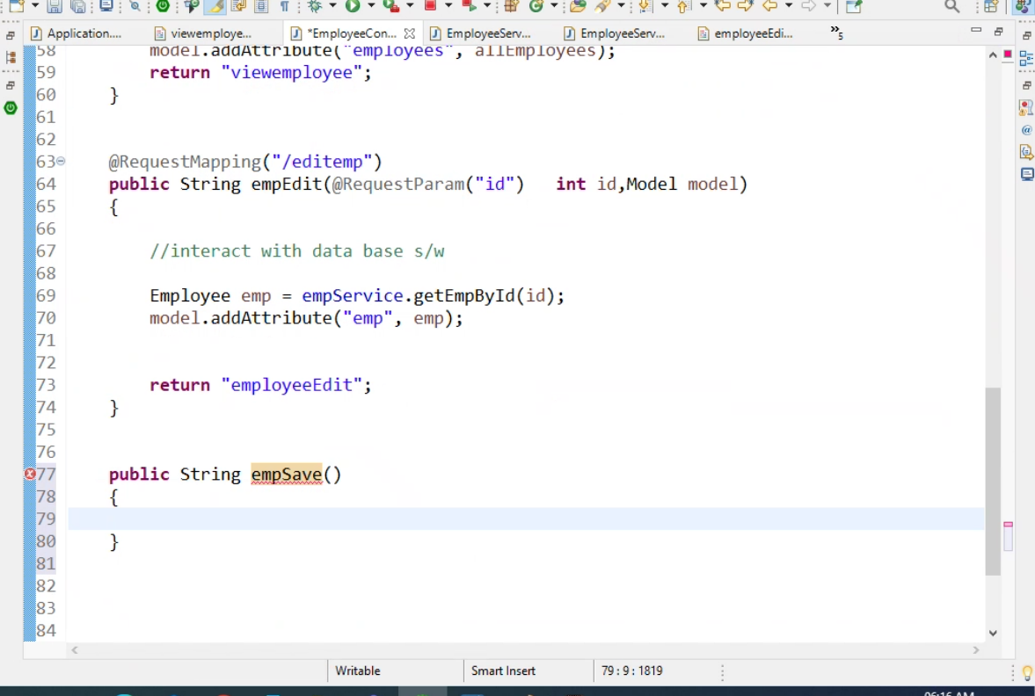 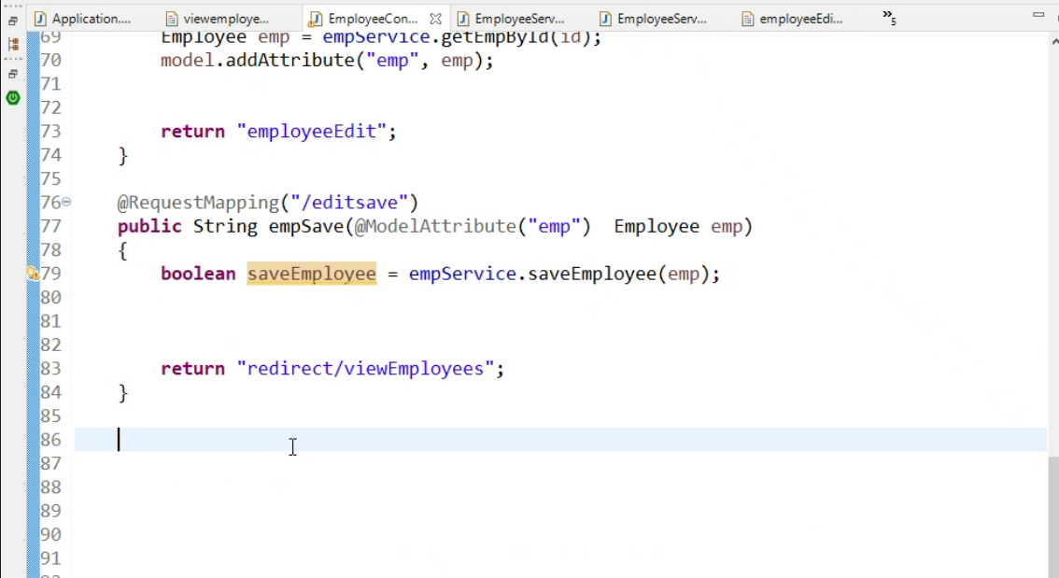

Run from command: java –jar lombok.jar